As a data analyst,

you'll be required to focus on a lot of different things,

And your stakeholders' expectations are

one of the most important.

We're going to talk about why

stakeholder expectations are so important to

your work and look at

some examples of stakeholder needs on a project.

By now you've heard me use the term stakeholder a lot.

So let's refresh ourselves on what a stakeholder is.

Stakeholders are people that

have invested time, interest,

and resources into the projects that

you'll be working on as a data analyst.

In other words, they hold stakes in what you're doing.

There's a good chance they'll need

the work you do to perform their own needs.

That's why it's so important to make

sure your work lines up with their needs

and why you need to communicate

effectively with all of

the stakeholders across your team.

Your stakeholders will want to

discuss things like the project objective,

what you need to reach that goal,

and any challenges or concerns you have.

This is a good thing.

These conversations help build

trust and confidence in your work.

Here's an example of

a project with multiple team members.

Let's explore what they might need from

you at different levels to reach the project's goal.

Imagine you're a data analyst working with

a company's human resources department.

The company has experienced

an increase in its turnover rate,

which is the rate at which employees leave a company.

The company's HR department wants to know why that

is and they want you to help them

figure out potential solutions.

The Vice President of HR at this company is

interested in identifying any shared patterns

across employees who quit and seeing if there's

a connection to employee productivity and engagement.

As a data analyst,

it's your job to focus on

the HR department's question and

help find them an answer.

But the VP might be too busy to manage

day-to-day tasks or might not be your direct contact.

For this task, you'll be updating

the project manager more regularly.

Project managers are in charge of

planning and executing a project.

Part of the project manager's job is keeping the project

on track and overseeing the progress of the entire team.

In most cases, you'll need to give them regular updates,

let them know what you need to succeed and

tell them if you have any problems along the way.

You might also be working with other team members.

For example, HR administrators

will need to know the metrics you're

using so that they can design ways

to effectively gather employee data.

You might even be working with

other data analysts who are

covering different aspects of the data.

It's so important that you know who

the stakeholders and other team members are in

a project so that you can

communicate with them effectively and

give them what they need to move

forward in their own roles on the project.

You're all working together to give

the company vital insights into this problem.

Back to our example.

By analyzing company data,

you see a decrease in employee engagement and

performance after their first 13 months at the company,

which could mean that employees

started feeling demotivated or

disconnected from their work

and then often quit a few months later.

Another analyst who focuses on

hiring data also shares that

the company had a large increase

in hiring around 18 months ago.

You communicate this information

with all your team members and

stakeholders and they provide

feedback on how to share this information with your VP.

In the end, your VP decides to implement an in-depth

manager check-in with employees who are

about to hit their 12 month mark at the firm

to identify career growth opportunities, which

reduces the employee turnover

starting at the 13 month mark.

This is just one example of how you might

balance needs and expectations across your team.

You'll find that in pretty much every project

you work on as a data analyst,

different people on your team,

from the VP of HR to your fellow data analysts,

will need all your focus and

communication to carry the project to success.

Focusing on stakeholder expectations

will help you understand the goal of a project,

communicate more effectively across your team,

and build trust in your work.

Coming up, we'll discuss how to

figure out where you fit on your team

and how you can help move a project

forward with focus and determination.

Working with stakeholders

Your data analysis project should answer the business task and create opportunities for data-driven decision-making. That's why it is so important to focus on project stakeholders. As a data analyst, it is your responsibility to understand and manage your stakeholders’ expectations while keeping the project goals front and center.



You might remember that **stakeholders** are people who have invested time, interest, and resources into the projects that you are  working on. This can be a pretty broad group, and your project stakeholders may change from project to project. But there are three common stakeholder groups that you might find yourself working with: the executive team, the customer-facing team, and the data science team.

Let’s get to know more about the different stakeholders and their goals. Then we'll learn some tips for communicating with them effectively.

**Executive team**

The executive team provides strategic and operational leadership to the company. They set goals, develop strategy, and make sure that strategy is executed effectively. The executive team might include vice presidents, the chief marketing officer, and senior-level professionals who help plan and direct the company’s work. These stakeholders think about decisions at a very high level and they are looking for the headline news about your project first.  They are less interested in the details. Time is very limited with them, so make the most of it by leading your presentations with the answers to their questions. You can keep the more detailed information handy in your presentation appendix or your project documentation for them to dig into when they have more time.

For example, you might find yourself working with the vice president of human resources on an analysis project to understand the rate of employee absences. A marketing director might look to you for competitive analyses. Part of your job will be balancing what information they will need to make informed decisions with their busy schedule.

But you don’t have to tackle that by yourself. Your project manager will be overseeing the progress of the entire team, and you will be giving them more regular updates than someone like the vice president of HR. They are able to give you what you need to move forward on a project, including getting approvals from the busy executive team. Working closely with your project manager can help you pinpoint the needs of the executive stakeholders for your project, so don’t be afraid to ask them for guidance.



**Customer-facing team**

The customer-facing team includes anyone in an organization who has some level of interaction with customers and potential customers. Typically they compile information, set expectations, and communicate customer feedback to other parts of the internal organization. These stakeholders have their own objectives and may come to you with specific asks. It is important to let the data tell the story and not be swayed by asks from your stakeholders to find certain patterns that might not exist.

Let’s say a customer-facing team is working with you to build a new version of a company’s most popular product. Part of your work might involve collecting and sharing data about consumers’ buying behavior to help inform product features. Here, you want to be sure that your analysis and presentation focuses on what is actually in the data-- not on what your stakeholders hope to find.



**Data science team**

Organizing data within a company takes teamwork. There's a good chance you'll find yourself working with other data analysts, data scientists, and data engineers. For example, maybe you team up with a company's data science team to work on boosting company engagement to lower rates of employee turnover. In that case, you might look into the data on employee productivity, while another analyst looks at hiring data. Then you share those findings with the data scientist on your team, who uses them to predict how new processes could boost employee productivity and engagement. When you share what you found in your individual analyses, you uncover the bigger story. A big part of your job will be collaborating with other data team members to find new angles of the data to explore. Here's a view of how different roles on a typical data science team support different functions:

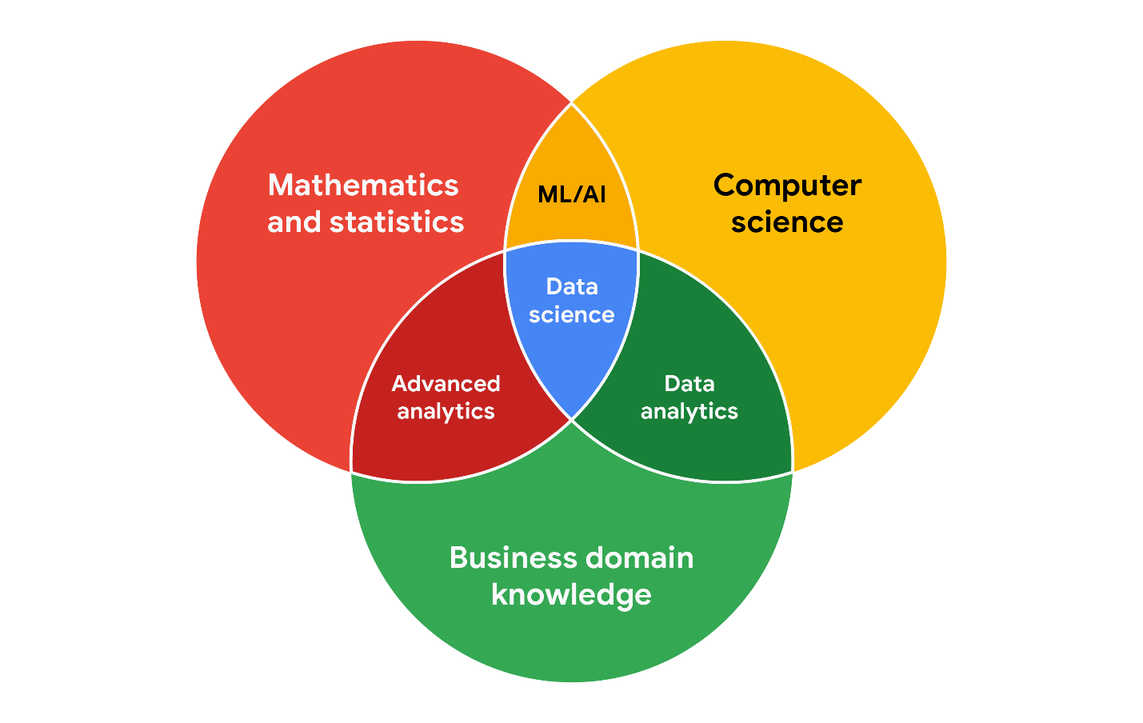

**Working effectively with stakeholders**

When you're working with each group of stakeholders- from the executive team, to the customer-facing team, to the data science team, you'll often have to go beyond the data. Use the following tips to communicate clearly, establish trust, and deliver your findings across groups.

**Discuss goals.** Stakeholder requests are often tied to a bigger project or goal. When they ask you for something, take the opportunity to learn more. Start a discussion. Ask about the kind of results the stakeholder wants. Sometimes, a quick chat about goals can help set expectations and plan the next steps.

**Feel empowered to say “no**.” Let’s say you are approached by a marketing director who has a “high-priority” project and needs data to back up their hypothesis. They ask you to produce the analysis and charts for a presentation by tomorrow morning. Maybe you realize their hypothesis isn’t fully formed and you have helpful ideas about a better way to approach the analysis. Or maybe you realize it will take more time and effort to perform the analysis than estimated. Whatever the case may be, don’t be afraid to push back when you need to.



Stakeholders don’t always realize the time and effort that goes into collecting and analyzing data. They also might not know what they actually need. You can help stakeholders by asking about their goals and determining whether you can deliver what they need. If you can’t, have the confidence to say “no,” and provide a respectful explanation. If there’s an option that would be more helpful, point the stakeholder toward those resources. If you find that you need to prioritize other projects first, discuss what you can prioritize and when. When your stakeholders understand what needs to be done and what can be accomplished in a given timeline, they will usually be comfortable resetting their expectations. You should feel empowered to say no-- just remember to give context so others understand why.

**Plan for the unexpected.** Before you start a project, make a list of potential roadblocks. Then, when you discuss project expectations and timelines with your stakeholders, give yourself some extra time for problem-solving at each stage of the process.

**Know your project.** Keep track of your discussions about the project over email or reports, and be ready to answer questions about how certain aspects are important for your organization. Get to know how your project connects to the rest of the company and get involved in providing the most insight possible. If you have a good understanding about why you are doing an analysis, it can help you connect your work with other goals and be more effective at solving larger problems.

**Start with words and visuals.** It is common for data analysts and stakeholders to interpret things in different ways while assuming the other is on the same page. This *illusion of agreement\**has been historically identified as a cause of projects going back-and-forth a number of times before a direction is finally nailed down. To help avoid this, start with a description and a quick visual of what you are trying to convey. Stakeholders have many points of view and may prefer to absorb information in words or pictures. Work with them to make changes and improvements from there. The faster everyone agrees, the faster you can perform the first analysis to test the usefulness of the project, measure the feedback, learn from the data, and implement changes.

**Communicate often.** Your stakeholders will want regular updates on your projects. Share notes about project milestones, setbacks, and changes. Then use your notes to create a shareable report. Another great resource to use is a change-log, which you will learn more throughout the program. For now, just know that a change-log is a file containing a chronologically ordered list of modifications made to a project. Depending on the way you set it up, stakeholders can even pop in and view updates whenever they want.



*\*Jason Fried, Basecamp,* [*www.inc.com/magazine/201809/jason-fried/illusion-agreement-team-project.html*](https://www.inc.com/magazine/201809/jason-fried/illusion-agreement-team-project.html)

As a data analyst, it’s important to communicate often. Sharing detailed notes and creating reports are ways to communicate with the people who have invested time and resources in a project. Who are these people?

**1 / 1 point**



Subject-matter experts



Stakeholders



Executives



Customer-facing team

**Correct**

Stakeholders invest time and resources into a project. Sharing detailed notes and creating reports are useful ways to keep them up-to-date.

### 2.

Question 2

The customer-facing team does which of the following activities? Select all that apply.

**1 / 1 point**



Compile information about customer expectations

**Correct**

The customer-facing team compiles information, shares feedback, and sets expectations.



Provide operational leadership for the company



Share customer feedback

**Correct**

The customer-facing team compiles information, shares feedback, and sets expectations.



Tell the data story to others

### 3.

Question 3

The human resources director approaches a data analyst to propose a new data analysis project. The analyst has a lot of experience in human resources and believes the director is taking the wrong approach, and it will lead to some problems. Select the data analyst’s best course of action.

**1 / 1 point**



Respectfully explain their viewpoints and offer the director some additional information to help improve the project.



Tell the director that they’re very sorry, but they can’t work on the project.



Politely explain that they’re too busy to take on another project at this time.



Complete the project as requested, but set aside some time in the future to fix the problems that are sure to come up.

**Correct**

The analyst should respectfully explain their viewpoints and offer the director some additional information to help improve the project.

1. **Ask**: Business Challenge/Objective/Question
2. **Prepare**: Data generation, collection, storage, and data management
3. **Process**: Data cleaning/data integrity
4. **Analyze**: Data exploration, visualization, and analysis
5. **Share**: Communicating and interpreting results
6. **Act**:  Putting your insights to work to solve the problem

**1.**

Question 1

Which of the following statements best defines data?

**1 point**



Data is an assortment of questions.



Data is a business process.



Data is a collection of facts.



Data is the use of calculations and statistics.

**2.**

Question 2

Fill in the blank: In data analytics, the data ecosystem refers to the various elements that interact with one another to produce, manage, store, \_\_\_\_\_, analyze, and share data.

**1 point**



locate



merge



organize



ingest

**3.**

Question 3

Which of the following terms refers to the collection, transformation, and organization of data in order to draw conclusions, make predictions, and drive informed decision-making?

**1 point**



Data insight



Data life cycle



Data analysis



Data elements

**4.**

Question 4

An airline collects, observes, and analyzes its customers' online behaviors. Then, it uses the insights gained to choose what new products and services to offer. What business process does this describe?

**1 point**



Performance measurement



Data-driven decision-making



Collaboration with stakeholders



Analytical thinking

**1.**

Question 1

Which of the following examples is an appropriate use of the discussion forum?

**1 point**



Sharing a photo of your new pet



Asking a question about a lesson from this program



Posting answers to quiz questions



Asking other learners to give your resume to their employer

**2.**

Question 2

In order to create clear and engaging discussions in the forum, which type of writing styles should you use? Select all that apply.

**1 point**



Writing in complete sentences



Writing in text message language, such as BTW for "by the way"



Typing in all lowercase



Including proper punctuation, such as commas and periods

**3.**

Question 3

When posting in the discussion forum, what type of behavior is acceptable?

**1 point**



Being sensitive, kind, and open-minded



Sharing advertisements and product promotions



Using cursing to emphasize your point



Conveying your opinion clearly by arguing against someone’s perspective

**1.**

Question 1

The collection, transformation, and organization of data in order to draw conclusions, make predictions, and drive informed decision-making describes what?

**1 point**



Data analysis



Data ecosystem



Data life cycle



Data science

**2.**

Question 2

In data analytics, a model is a group of elements that interact with one another.

**1 point**



True



False

**3.**

Question 3

Fill in the blank: Using data to create new ways of understanding and modeling the unknown is known as \_\_\_\_\_.

**1 point**



data science



data engineering



data design



data analysis

**4.**

Question 4

Fill in the blank: In data science, \_\_\_\_\_\_\_\_ is when a data analyst uses their unique past experiences to understand the story the data is telling.

**1 point**



gut instinct



rational thought



awareness



personal opinion

**5.**

Question 5

A data analyst at Billings Upholstery is trying to find more environmentally friendly way to produce furniture. The data analyst gathers relevant data, analyzes it, and uses it to draw conclusions. Then they share this analysis with subject-matter experts in manufacturing. Once the subject-matter experts have reviewed the analysis, a plan is put into action. What process does this scenario describe?

**1 point**



Customer service



Identification of trends



Data science



Data-driven decision-making

**6.**

Question 6

You have just received the results of your latest analysis about the effectiveness of your firm’s recent marketing campaign. However, because you want to follow data-driven decision-making you share your results with colleagues from the marketing department for their validation. In this role, these colleague’s are acting as what?

**1 point**



customers



subject-matter experts



competitors



stakeholders

**7.**

Question 7

You have just finished analyzing data for a marketing project. Before moving forward, you share your results with members of the marketing team to see if they might have additional insights into the business problem. What process does this support?

**1 point**



Data-driven decision-making



Data science



Data management



Data analytics

**8.**

Question 8

You read an interesting article in a magazine and want to share it in the discussion forum. What should you do when posting? Select all that apply.

**1 point**



Check your post for typos or grammatical errors



Take credit for creating the article



Make sure the article is relevant to data analytics



Include your email address for people to send questions or comments

Description

The analytical skill that involves how you organize information

Skill

Data design

Description

The qualities and characteristics associated with solving problems using facts

Skill

Analytical skills

Description

The analytical skill that has to do with how you group things into categories

Skill

Understanding context

Description

The analytical skill that involves managing the processes and tools used in data analysis

Skill

Data strategy

Description

The analytical skill that involves breaking processes down into smaller steps and working with them in an orderly, logical way

Skill

A technical mindset

To execute a plan using detail-oriented thinking, what does a data analyst consider?



The big picture



The main idea



The specifics



The root cause

**1.**

Question 1

What practice involves identifying, defining, and solving a problem by using data in an organized, step-by-step manner?

**1 / 1 point**



Visualization



Analytical thinking



Context



Data design

**Correct**

Analytical thinking involves identifying and defining a problem, then solving it by using data in an organized, step-by-step manner.

**2.**

Question 2

Which of the following are examples of data visualizations? Select all that apply.

**1 / 1 point**



Maps

**Correct**

Graphs, maps, and charts are used in data visualization.



Charts

**Correct**

Graphs, maps, and charts are used in data visualization.



Graphs

**Correct**

Graphs, maps, and charts are used in data visualization.



Reports

**3.**

Question 3

Gap analysis is used to examine and evaluate how a process currently works with the goal of getting to where you want to be in the future.

**1 / 1 point**



True



False

**Correct**

Gap analysis is used to examine and evaluate how a process currently works with the goal of getting to where you want to be in the future.

**4.**

Question 4

Which aspect of analytical thinking involves being able to identify a relationship between two or more pieces of data?

**1 / 1 point**



Visualization



Context



Data design



Correlation

**Correct**

Correlation involves being able to identify a relationship between two or more pieces of data. A correlation is like a relationship.

**1.**

Question 1

Fill in the blank: Curiosity, understanding context, and having a technical mindset are all examples of \_\_\_\_\_ used in data-driven decision-making.

**1 / 1 point**



data models



analytical skills



thought processes



business strategies

**Correct**

Curiosity, understanding context, and having a technical mindset are all examples of analytical skills used to make data-driven decisions.

**2.**

Question 2

Surveying customers about their preferences and using that information to inform business strategy is an example of data-driven decision-making.

**1 / 1 point**



True



False

**Correct**

Surveying customers about their preferences and using that information to inform business strategy is an example of data-driven decision-making.

**3.**

Question 3

In data analysis, which analytical skill involves the management of people, processes, and tools?

**1 / 1 point**



Data control



Data design



Data analytics



Data strategy

**Correct**

Data strategy involves the management of the people, processes, and tools.

**1.**

Question 1

Fill in the blank: The analytical skill of \_\_\_\_\_\_ involves seeking out new experiences in order to gain knowledge.

**1 point**



curiosity



having a technical mindset



data strategy



understanding context

**2.**

Question 2

Adding descriptive headers to columns of data in a spreadsheet is an example of which analytical skill?

**1 point**



Having a technical mindset



Understanding context



Curiosity



Data strategy

**3.**

Question 3

A technical mindset involves the ability to break things down into smaller steps or pieces and work with them in an orderly and logical way.

**1 point**



True



False

**4.**

Question 4

Fill in the blank: Data strategy involves \_\_\_\_\_ the people, processes, and tools used in data analysis.

**1 point**



managing



choosing



visualizing



supervising

**5.**

Question 5

Identifying a relationship between two or more pieces of data is known as what?

**1 point**



problem-orientation



correlation



detail-oriented thinking



visualization

**6.**

Question 6

The five whys is a technique that involves asking, “Why?” five times in order to achieve what goal?

**1 point**



Visualize how a process should look in the future



Identify the root cause of a problem



Use facts to guide business strategy



Put a plan into action

**7.**

Question 7

In data analysis, one often examines and evaluates how a process currently works in order to get it to where they want it to be in the future. This is known as what?

**1 point**



Asking the five whys



Gap analysis



Determining the stakeholders



Building a data visualization

**8.**

Question 8

Fill in the blank: Data analysts use the five analytical skills of curiosity, understanding context, having a technical mindset, data design, and data strategy to make \_\_\_\_\_ decisions.

**1 point**



forward-looking



intuitive



more efficient



data-driven

**1.**

Question 1

Fill in the blank: During the \_\_\_\_\_ phase of the data life cycle, a business decides what kind of data it needs, how it will be managed, who will be responsible for it, and the optimal outcomes.

**1 point**



planning



manage



archive



capture

**2.**

Question 2

In the data life cycle, which phase involves gathering data from various sources and bringing it into the organization?

**1 point**



Manage



Archive



Capture



Analyze

**3.**

Question 3

A data analyst finishes using a dataset, so they erase or shred the files in order to protect private information. This is called archiving.

**1 point**



True



False

**4.**

Question 4

A dairy farmer decides to open an ice cream shop on her farm. After surveying the local community about people’s favorite flavors, she takes the data they provided and stores it in a secure hard drive so it can be maintained safely on her computer. This is part of which phase of the data life cycle?

**1 point**



Archive



Manage



Plan



Analyze

**5.**

Question 5

After opening the ice cream shop on her farm, the same dairy farmer then surveys the local community about people’s favorite flavors. She uses the data she collected to determine that the top five flavors are strawberry, vanilla, chocolate, mint chip, and peanut butter. She feels confident in her decision to sell these flavors. This is part of which phase of the data life cycle?

**1 point**



Capture



Analyze



Archive



Plan

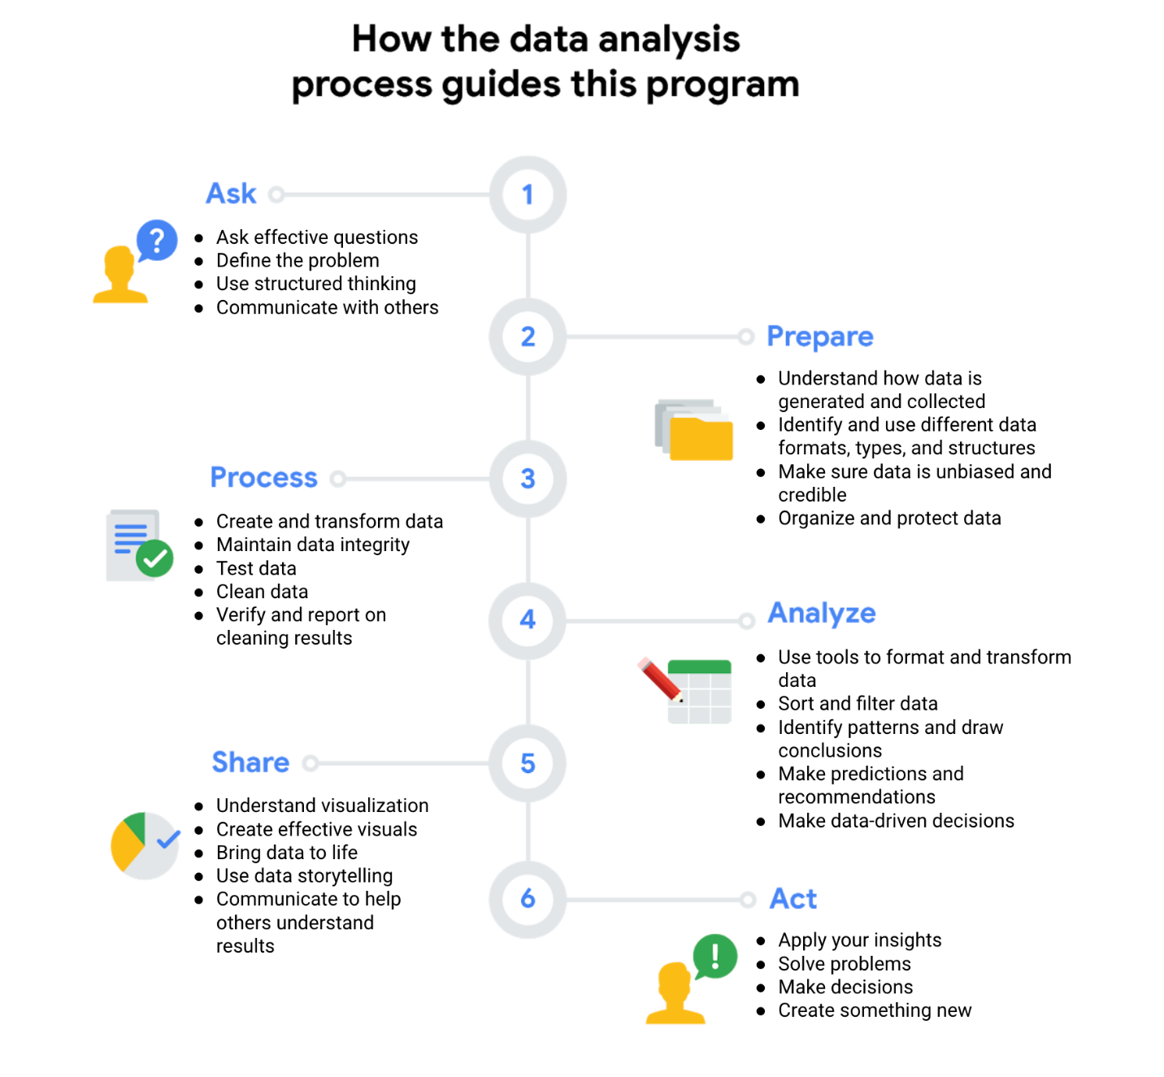

Data analysts spend a lot of time organizing data and performing

calculations.

Luckily, there's lots of different tools to help them do just that,

including spreadsheets. In this video we'll take a look at some of the ways data

analysts use spreadsheets to help them with their day to day responsibilities.

Later, you'll get to test out some of these things yourself, but for now,

let's start with a quick look at how data analysts use spreadsheets to do

their jobs.

This will change depending on the work you need to complete.

But here's an overview of a few of the major tasks.

Imagine you work for a construction company.

Your company needs your spreadsheet skills to analyze some data about their expenses,

so you access the appropriate data and add it to your spreadsheet.

We won't cover all the details of this project right now, but

you will get a chance to see lots of spreadsheet features up close and

personal as we move forward.

What do you do with the data now that it's in your spreadsheet? Again,

this will be different for each job, but

you might start by organizing your data with the task you've been given.

For example, you might put your data in a pivot table.

We've talked about pivot tables before in this course. We'll cover

them in more detail later on, but for now, just think of them as

well organized and very useful tables.

Next, you might filter the data in the pivot table.

Sorting and filtering data is a common part of most jobs.

This lets you focus only on the data you'll need for your analysis.

In our example, maybe you only need the expenses for a certain time frame,

like the last three months. After you filtered your data,

you could perform some calculations to learn more about it.

Maybe you need to find out which construction projects ended up costing

the most money.

This is where formulas and functions are really handy.

We'll talk about them in just a bit, but formulas and functions are great for

doing some quick math, especially once you run out of fingers and toes to count on.

Now you've seen some of the ways data analysts are using spreadsheets in their

day to day work for a lot of different tasks,

including organizing their data and making calculations. Before you know it we'll

have you working in your own spreadsheets.

Spreadsheets and the data life cycle

To better understand the benefits of using spreadsheets in data analytics, let’s explore how they relate to each phase of the data life cycle: **plan, capture, manage, analyze, archive,** and **destroy**.

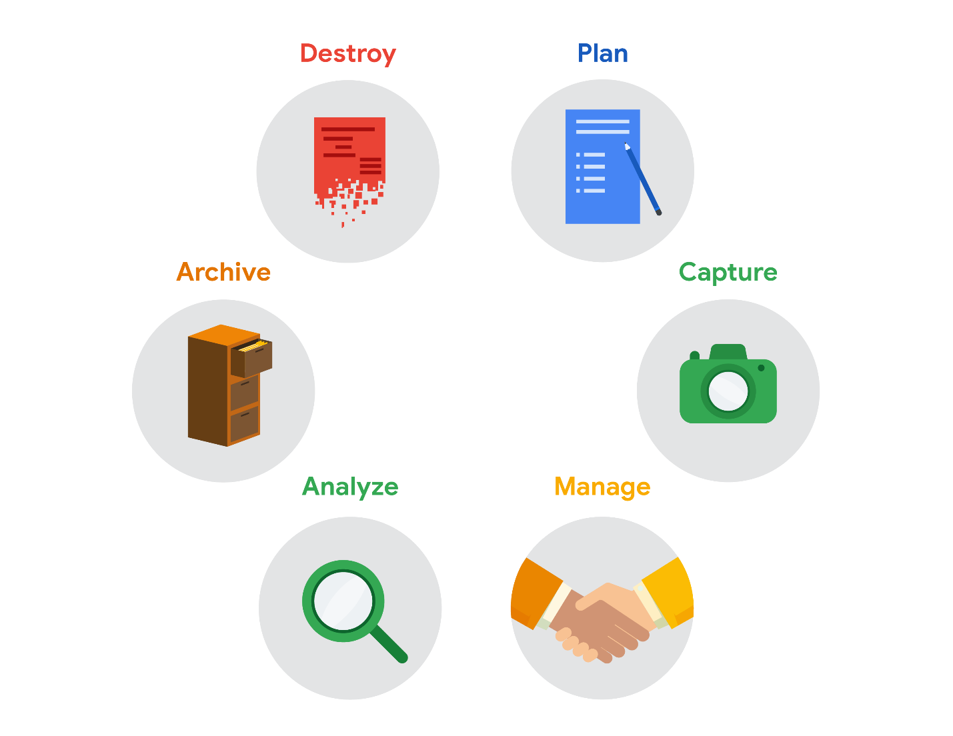

* **Plan** for the users who will work within a spreadsheet by developing organizational standards. This can mean formatting your cells, the headings you choose to highlight, the color scheme, and the way you order your data points. When you take the time to set these standards, you will improve communication, ensure consistency, and help people be more efficient with their time.
* **Capture** data by the source by connecting spreadsheets to other data sources, such as an online survey application or a database. This data will automatically be updated in the spreadsheet. That way, the information is always as current and accurate as possible.
* **Manage** different kinds of data with a spreadsheet. This can involve storing, organizing, filtering, and updating information. Spreadsheets also let you decide who can access the data, how the information is shared, and how to keep your data safe and secure.
* **Analyze** data in a spreadsheet to help make better decisions. Some of the most common spreadsheet analysis tools include formulas to aggregate data or create reports, and pivot tables for clear, easy-to-understand visuals.
* **Archive** any spreadsheet that you don’t use often, but might need to reference later with built-in tools. This is especially useful if you want to store historical data before it gets updated.
* **Destroy** your spreadsheet when you are certain that you will never need it again, if you have better backup copies, or for legal or security reasons. Keep in mind, lots of businesses are required to follow certain rules or have measures in place to make sure data is destroyed properly.

**Resources**

Spreadsheet shortcuts can help you become more efficient with spreadsheets. If you’d like to learn more, you can explore the collection of [Google Sheets shortcuts](https://support.google.com/docs/answer/181110), or visit the [Microsoft Excel shortcuts](https://support.microsoft.com/en-us/office/keyboard-shortcuts-in-excel-1798d9d5-842a-42b8-9c99-9b7213f0040f) page if you are using Excel. Both of these resources contain a list of spreadsheet shortcuts you can save and reference as you work more with spreadsheets on your own.

We've talked about how spreadsheets are great

for organizing data and performing calculations.

Now, it's time to get our hands

dirty and start building a real spreadsheet.

In this video, I'm going to demonstrate some basic tasks

we know data analysts use spreadsheets

for, including entering and organizing data.

We'll start with a step-by-step process to show

you some tools to organize your data in a spreadsheet.

Consider these steps the basics.

You won't always have to use

them when working with a data set,

but if your data is a bit messy when you get it,

these steps can help you get it ready for analysis.

Let's start by opening a new spreadsheet.

As a data analyst,

you might not start with a blank spreadsheet,

but it's good to know how to do it, just in case.

Start by opening Excel,

Google Sheets or whatever

spreadsheet software you're using,

then select a new blank file.

The first thing you'll want to do when you open

a new spreadsheet is give it a title. Here's a pro tip.

Make your title short, clear,

and have it state exactly what

the data in the spreadsheet is about.

Trust me, it'll make searching for it a lot easier.

Creating a folder on your computer specifically for

spreadsheets and related files

can also make it easier to find them.

For this spreadsheet, it's already saved in our drive.

So we'll open our File menu to click Move.

Play video starting at :1:26 and follow transcript1:26

Then we'll create a new folder,

name it "Population Data,"

Play video starting at :1:36 and follow transcript1:36

and move the spreadsheet there.

Play video starting at :1:41 and follow transcript1:41

Our spreadsheet now has a new home.

This will save you a lot of

unnecessary clicks and headaches

when you look for this file.

There's a few different ways data analysts

get data they work with.

Depending on the job,

you might use data from an open source,

you might be given data to work with

or you might be asked to find your own data.

You'll experience all of these later in the program.

There's a lot of open data sources online,

where data is made available to the public.

For example, we'll use data from worldbank.org,

that's already in the spreadsheet.

The data shows the population of

Latin American and Caribbean countries from 2010-2019.

Let's open this spreadsheet.

Time to get the data ready for analysis.

We'll start by selecting the whole sheet and

making our columns wider by

dragging the boundary of one of the columns.

Play video starting at :2:37 and follow transcript2:37

This will help us see the data clearly,

then we can adjust

any individual columns that need it.

You can make columns wider in other ways as well,

but this will work for now.

The first row of the spreadsheet is for

data attributes or variables.

It's basically labeling the type of data in each column.

Let's make the attributes stand out from the rest of

the rows by selecting it and filling it with color.

We'll also make the labels bold.

Play video starting at :3:10 and follow transcript3:10

If we want to add another data attribute

between two of the other attributes,

we can always add a new column.

Just click on any cell within

a column and use the Insert menu to add a new one.

Play video starting at :3:29 and follow transcript3:29

It will appear next to the column you

originally clicked, pretty simple.

Deleting a column is just as simple.

To delete, right-click in

a cell in the column you want to get rid of.

The steps we're showing may be different

depending on the spreadsheet program you're using,

but should be pretty similar.

Let's add one more thing to our data table: borders.

This can help you see each piece of data more clearly.

To add borders start by clicking the Select

All button at the top left corner of your spreadsheet.

This is like a magic button because you can click it

whenever you need to make

changes to every cell in your spreadsheet.

Then click the Border button in

the menu, and choose the type of borders you want.

To keep our spreadsheets uniform,

we'll choose borders for all cells.

Just like that, we've gone from raw to refined.

Now our spreadsheet is filled with

data and it's nice to look at too.

Using these organization tools before you analyze can

help you focus on the data once you start your analysis.

Now that we've gone over some ways

spreadsheets can be used to organize data,

you're ready to start working on them yourself.

Later you'll learn more about spreadsheets,

including some common errors and how to fix them.

Learn more about spreadsheet basics

Below, you will find a list that covers two types of spreadsheet programs: **Microsoft Excel** and **Google Sheets**. The list includes quick-start guides, tutorials, and more. The examples in this course use Google Sheets, but you can follow along using Excel or any other spreadsheet application. The user interface might be a little different, but it should look and work similarly.



**Microsoft Excel**

* [Office Quick Starts](https://support.microsoft.com/en-us/office/office-quick-starts-25f909da-3e76-443d-94f4-6cdf7dedc51e#ID0EAADAAA=At_work_or_school): Scroll down to the **Downloadable guides** section to download the **Excel Quick Start Guide**: This PDF guide begins with a labeled map of Excel that can guide you through the basic tasks you can accomplish in Excel. For tips on starting and opening Excel, this [Microsoft Support page](https://support.microsoft.com/en-us/office/create-a-new-workbook-ae99f19b-cecb-4aa0-92c8-7126d6212a83?wt.mc_id=otc_excel) will show you how to begin a new workbook.
* [Excel video training](https://support.microsoft.com/en-us/office/excel-for-windows-training-9bc05390-e94c-46af-a5b3-d7c22f6990bb?wt.mc_id=otc_home): This is a collection of step-by-step videos to use all sorts of Excel features, including adding and working within rows, columns, and cells; formatting; using formulas and functions; and adding charts and pivot tables.
* [Sort data in a range or table](https://support.microsoft.com/en-us/office/sort-data-in-a-range-or-table-62d0b95d-2a90-4610-a6ae-2e545c4a4654): This page guides you through all of the steps you will need to sort data by number, text, and color. You’ll also have the option to sort by custom list so that you can customize exactly what you want to sort.
* [Filter data in a range or table](https://support.microsoft.com/en-us/office/filter-data-in-a-range-or-table-01832226-31b5-4568-8806-38c37dcc180e): This article has step-by-step instructions on how to filter an Excel spreadsheet to show only the data you want to see. You can also use built-in comparison operators, such as “greater than” and “top 10” to reveal only the most relevant data.
* [Format a worksheet](https://support.microsoft.com/en-us/office/quick-start-format-a-worksheet-d70f75a2-23e6-4c92-83d6-2f219e4ad42e): The guide will help you select and format your Excel spreadsheet, then change the borders, shading, colors, and text. This can help improve your spreadsheet’s readability.

**Pro tip**: If you’re searching for information about using customizable options, check out Microsoft’s [Guidelines for organizing and formatting data on a worksheet](https://support.microsoft.com/en-us/office/guidelines-for-organizing-and-formatting-data-on-a-worksheet-90895cad-6c85-4e02-90d3-8798660166e3). This article provides clear methods for creating easy-to-read spreadsheets.

**Google Sheets**

* [Google Sheets cheat sheet](https://support.google.com/a/users/answer/9300022): The cheat sheet puts all the basics of Sheets on a single page for easy reference. Here, you can learn about customizing your spreadsheet and the data inside; working with rows, columns, and cells; sharing your spreadsheet with others; creating different versions and copies of a spreadsheet; and more.
* [Get started with Sheets: Create and import files](https://support.google.com/a/users/answer/9300311?hl=en&ref_topic=9296423): This guide is a step-by-step guide for working with Sheets. You start by learning how to open a spreadsheet, then move on to adding data.
* [Sort and filter your data](https://support.google.com/docs/answer/3540681?co=GENIE.Platform%3DDesktop&hl=en): This resource can help you organize data in Sheets. Use this guide to sort part or all of a spreadsheet. You can sort by text, number, and color. Then, learn how to create filters to show only certain data while hiding the rest. Finally, the article includes information on creating, saving, and removing a filter view.
* [Edit and format a spreadsheet](https://support.google.com/docs/answer/46973?co=GENIE.Platform%3DDesktop&hl=en&oco=0): This will help you make easy-to-read spreadsheets. You will learn how to assign a color, customize borders around cells, and change the appearance of text. If you’d like to give your spreadsheet a theme, you can scroll to the bottom of the page and find how to apply it to parts of your spreadsheet.

**Tip**: Microsoft Excel and Google Sheets are very similar in terms of calculations, formulas, functions, and many other features. But there are some differences, which can make it tricky to switch from one to the other. If you are moving between Excel and Google Sheets, find a quick list of the differences between the two kinds of spreadsheet applications in [Overview: Differences between Sheets and Excel](https://support.google.com/a/users/answer/9331278?hl=en).

## Transcript



Help Us Translate

### **Interactive Transcript - Enable basic transcript mode by pressing the escape key**

You may navigate through the transcript using tab. To save a note for a section of text press CTRL + S. To expand your selection you may use CTRL + arrow key. You may contract your selection using shift + CTRL + arrow key. For screen readers that are incompatible with using arrow keys for shortcuts, you can replace them with the H J K L keys. Some screen readers may require using CTRL in conjunction with the alt key

Play video starting at :: and follow transcript0:00

So far we've covered how to start a new spreadsheet,

enter in data, and make it look

refined and ready for some serious analysis.

Now we'll learn how to perform

calculations in your spreadsheet.

You may need to calculate everything

from sums to averages,

to finding minimum and maximum amounts.

You'll use calculations for

a lot of different kinds of tasks.

In this video, we'll focus on learning the basics

and then do a little math with

some sales data to practice.

Let's talk about formulas first.

You might remember that a formula is a set of

instructions that perform a specific calculation.

Basically, formulas can do the math for you.

Now, they don't only do math,

they can do a lot more.

Soon you'll learn different ways you can use

them throughout the data analysis processes.

Formulas are built on operators which are symbols that

name the type of operation or

calculation to be performed.

For example, a plus sign is a common operator.

The formulas you use as a data analyst will

usually include at least one operator.

Now, let's talk about math expressions or equations.

These can take a lot of different forms,

but you might be familiar with them already.

3 minus 1, 15 plus 8 divided by 2, 846 times 513.

These are all examples of expressions.

Is this bringing back memories of grade school?

Well, back in math class,

you most likely learned to complete an expression by

including an equal sign and the solution.

It's slightly different with spreadsheets.

When you create a formula using

an expression in a spreadsheet,

you start the formula with an equal sign.

For example, if we want to subtract,

we type an equal sign followed by the rest of

the expression without any spaces in the formula.

Now let's try an expression

that's a bit more challenging.

We'll type 31982, then

a hyphen for a minus sign, then 17795.

To calculate, we press "Enter."

You'll most likely use

formulas this way when dealing with

large numbers or expressions with multiple steps.

Here are the operators you will use to complete formulas.

The plus sign for addition,

the minus or hyphen for subtraction,

the asterisk for multiplication,

and the forward slash for division.

The division and multiplication symbols

might be different than what you're used to.

Small changes, but important to keep in mind.

If you already have data in your spreadsheet,

you can use cell references in your formulas instead.

A cell reference is a single cell or

range of cells in

a worksheet that can be used in a formula.

Cell references contain the letter of

the column and the number of the row where the data is.

A range of cells is a collection of two or more cells.

A range can include cells from the same row or column,

or from different columns and rows collected together.

We'll show you an example in an upcoming video.

Now let's apply what we just learned to some sales data.

If we want to add these figures to find

the total sales for the first row of data,

you can click "cell F2".

From there, we'll start with an equal sign and use

the cell references to input values in your expression.

We're starting with cell B2 because the year in

A2 is not a value we want to add to the total.

Play video starting at :3:38 and follow transcript3:38

Then press "Enter."

Just like that,

your total sales has been calculated for you,

but what if you realized one of

the values in your data was wrong?

No problem.

You can change the value in any cell using

the formula and the total will update automatically.

Play video starting at :4:3 and follow transcript4:03

The great thing about using cell references is that they

also automatically update when

a formula is copied to a new cell.

Talk about a time-saver.

Instead of entering the same formula again

for every new set of cell references,

just copy the formula using

the menu or a keyboard shortcut like Control plus C.

Play video starting at :4:26 and follow transcript4:26

Then paste the formula where you want to apply it using

Control plus V. And presto!

The formula updates

all the new cells and values correctly.

Now let's say you also want it to find the average sales.

For this, you create a new formula in a different cell.

Play video starting at :4:57 and follow transcript4:57

To group values in a formula, use parentheses.

This lets your spreadsheet know which values to calculate

together and the order of the operations to be performed.

For example, open parentheses,

then B2 plus C2 plus D2 plus E2,

and close parentheses, then divide

the value of all of this by typing slash four.

You are adding the values in the four cells together

and then using the slash to divide the total by four,

and just like the last one,

we can copy and paste the formula.

Here's another formula you can use if you want to find

the percent change in sales between June and July.

Play video starting at :5:56 and follow transcript5:56

Once a formula calculates the value,

you can then use the percent button

to change the value to a percentage.

When you apply the formula to the other rows,

both the formula and

the percent will automatically update.

That doesn't look like the right answer.

Looks like we've got an error. Don't worry.

Errors can happen at any stage of data analysis,

and that includes when you're using spreadsheets.

A formula has to be air tight.

If there's something wrong with one of

the cell references, it won't work.

So what's our error?

Well, we can see that the value in cell D4 is missing.

It might take some time and research on

your part to find the correct value, but it's worth it.

You want your analysis to be as accurate as possible.

When you do add the value,

the formula takes care of the rest.

Play video starting at :6:49 and follow transcript6:49

That was a lot to take in.

Thanks for staying with me.

You'll be able to apply what you

learned about formulas here and later

in the program to make

your analysis more efficient and your job,

a little easier, and

soon you'll work in your own spreadsheet.

Happy spreadsheeting.

# Quick reference: Formulas in spreadsheets



You have been learning a lot about spreadsheets and all kinds of time-saving calculations and organizational features they offer. One of the most valuable spreadsheet features is a **formula**. As a quick reminder, a formula is a set of instructions that does a specific calculation using the data in a spreadsheet. Formulas make it easy for data analysts to do powerful calculations automatically, which helps them analyze data more effectively. Below is a  quick-reference guide to help you get the most out of formulas.

## Formulas

### **The basics**

* When you write a formula in math, it generally ends with an equal sign (2 + 3 = ?). But with formulas, they always start with one instead (=A2+A3). The equal sign tells the spreadsheet that what follows is part of a formula, not just a word or number in a cell.
* After you type the equal sign, most spreadsheet applications will display an autocomplete menu that lists valid formulas, names, and text strings. This is a great way to create and edit formulas while avoiding typing and syntax errors.
* A fun way to learn new formulas is just by typing an equal sign and a single letter of the alphabet. Choose one of the options that pops up and you will learn what that formula does.

### **Mathematical operators**

* The mathematical operators used in spreadsheet formulas include:
* Subtraction – minus sign ( - )
* Addition – plus sign ( + )
* Division – forward-slash ( / )
* Multiplication – asterisk ( \* )

### **Auto-filling**

The lower-right corner of each cell has a fill handle. It is a small green square in Microsoft Excel and a small blue square in Google Sheets.

* Click the fill handle for a cell and drag it down a column to auto-fill other cells in the column with the same value or formula in that cell.
* Click the fill handle for a cell and drag it across a row to auto-fill other cells in the row with the same value or formula in that cell.
* If you want to create a numbered sequence in a column or row, do the following: 1) Fill in the first two numbers of the sequence in two adjacent cells, 2) Select to highlight the cells, and 3) Drag the fill handle to the last cell to complete the sequence of numbers. For example, to insert 1 through 100 in each row of column A, enter **1** in cell A1 and **2** in cell A2. Then, select to highlight both cells, click the fill handle in cell A2, and drag it down to cell A100. This auto-fills the numbers sequentially so you don't have to type them in each cell.

### **Absolute referencing**

* Absolute referencing is marked by a dollar sign ($). For example, =$A$10 has absolute referencing for both the column and the row value
* Relative references (which is what you normally do e.g. “=A10”) will change anytime the formula is copied and pasted. They are in relation to where the referenced cell is located. For example if you copied “=A10” to the cell to the right it would become “=B10”. With absolute referencing “=$A$10” copied to the cell to the right would remain “=$A$10”. But if you copied $A10 to the cell below, it would change to $A11 because the row value isn't an absolute reference.
* Absolute references will not change when you copy and paste the formula in a different cell. The cell being referenced is always the same.
* To easily switch between absolute and relative referencing in the formula bar, highlight the reference you want to change and press the F4 key; for example, if you want to change the absolute reference, $A$10, in your formula to a relative reference, A10, highlight $A$10 in the formula bar and then press the F4 key to make the change.

### **Data range**

* When you click into your formula, the colored ranges let you see which cells are being used in your spreadsheet. There are different colors for each unique range in your formula.
* In a lot of spreadsheet applications, you can press the F2 (or Enter) key to highlight the range of data in the spreadsheet that is referenced in a formula. Click the cell with the formula, and then press the F2 (or Enter) key to highlight the data in your spreadsheet.

### **Combining with functions**

* COUNTIF() is a formula and a function. This means the function runs based on criteria set by the formula. In this case, COUNT is the formula; it will be executed IF the conditions you create are true. For example, you could use =COUNTIF(A1:A16, “7”) to count only the cells that contained the number 7. Combining formulas and functions allows you to do more work with a single command.
* Hi and welcome back.
* Recently we've been learning about formulas.
* Sometimes data analysts encounter
* a problem with our formulas and we get an error.
* We've all been there and it can be frustrating.
* But there are solutions,
* that's what we're going to explore in this video.
* One error you may encounter is the DIV error.
* The DIV error happens when a formula is trying to divide
* a value in a cell by zero or by an empty cell.
* In this spreadsheet,
* the percentage Complete values in
* column C are calculated by
* dividing the values in
* the Tasks Completed column by
* the values in the Required Tasks column.
* Notice that column C is
* already formatted as a percentage.
* The DIV error is in cell C4 because we're
* dividing by zero the value in cell A4.
* To avoid this problem,
* we can have this spreadsheet
* automatically enter not applicable
* whenever a cell in column A
* contains a zero that would cause the error.
* To do this, we'll use the IFERROR function.
* If it encounters a DIV error
* caused by a cell that contains the zero,
* the phrase "Not applicable" will be inserted.
* Play video starting at :1:17 and follow transcript1:17
* We can also copy the formula to the rest of the cells in
* column C so it checks for
* any other cells that contain a zero.
* Now let's move on to ERROR.
* In Google Sheets,
* ERROR tells us the formula can't
* be interpreted as it is input.
* This is also known as a parsing error.
* Say we want to tally the number of
* total tasks in column B and C,
* we use the SUM function,
* but the formula equal sum B2 to B6,
* C2 to C6 causes an error.
* Examining it more closely,
* we see that a comma is missing between
* the cell ranges B2 to B6 and C2 to C6.
* We can fix this by inserting a comma between the cell
* ranges to indicate the end of each data item.
* This is called a delimiter,
* which you will learn more about soon.
* Now, the formula can correctly
* calculate the total number of tasks as 25.
* Another type of error is N/A.
* The N/A error tells you that the data
* in your formula can't be found by the spreadsheet.
* Generally, this means the data doesn't exist.
* This error most often occurs
* when using functions such as VLOOKUP,
* which searches for a certain value in a column
* to return a corresponding piece of information.
* Here, we see a master list of nuts and their prices.
* Using VLOOKUP, the spreadsheet finds prices in the list,
* then calculates the prices for
* each store using the assigned markup.
* But we have a N/A error in cells B49 and C49.
* The VLOOKUP formula is correct,
* so what's going on?
* Well, if we look carefully at the name of the nut,
* "almond" has no match in the lookup table,
* the lookup table uses the plural "almonds" instead.
* So we change almond to almonds,
* and with that typo fixed,
* the right prices are filled in.
* Speaking of typos, sometimes
* a typo can cause a NAME error.
* A NAME error can happen when
* a formula's name isn't recognized or understood.
* Suppose we see a NAME error
* in the nut prices spreadsheet.
* If we look carefully,
* the VLOOKUP function in cell B21 is spelled incorrectly,
* it has one extra O;
* this causes a NAME error for
* both the price and
* the resulting markup calculation for the store.
* To fix this error,
* we can delete the extra O in VLOOKUP.
* Play video starting at :4:7 and follow transcript4:07
* Perfect. Sometimes an error
* is caused by inconsistent or wrong data.
* For instance, the NUM error tells us that
* a formula's calculation can't
* be performed as specified by the data.
* The data doesn't make sense for that calculation.
* Here's what I mean.
* Suppose we're working on
* a large construction project using
* a spreadsheet to track
* how many months it takes to reach key milestones.
* We can use the DATEDIF function to
* calculate the number of months
* between start and end dates.
* The function requires the start date
* to be in the first cell
* referenced and the end date
* to be in the second cell referenced.
* In our case, cells B2 and C2 respectively.
* The M represents months,
* as we want this spreadsheet to calculate the number of
* months between our start and end dates.
* But we get a NUM error in cell D6.
* We notice that the end date comes before the start date,
* so the DATEDIF function
* can't calculate the number of months between.
* It's likely the start and end dates
* were interchanged by accident.
* We can request verification of the data to make sure.
* In the meantime, let's reverse the order of
* the cells in the formula to
* temporarily get around the error.
* Now, the result is nine months.
* What if the client's name was accidentally
* inserted into the start date in the spreadsheet?
* You guessed it, we get an error.
* The VALUE error can indicate
* a problem with a formula or referenced cells.
* It's often not clear right away what the problem is,
* so this error might take a little more effort to fix.
* In this case, John Welty was input as the start date,
* making the calculation impossible for
* the DATEDIF function in the cell D6.
* We just replace the text, John Welty,
* with the correct start date of September 1st, 2016.
* Play video starting at :6:18 and follow transcript6:18
* Last is the REF error,
* which often comes up when cells being
* referenced in a formula have been deleted,
* thus making the formula unable
* to perform the calculation.
* Here's a spreadsheet used to calculate
* the number of seats available for a company lunch.
* Let's say the company
* decided not to run the second floor,
* so we delete row 4.
* This results in a REF error when
* calculating the total seats available in cell B5.
* To fix this, we can change the formula to
* add the values in cells B2 and B3.
* Also, in this case,
* we could have prevented
* the REF error by using the SUM function and
* a range of cells instead of adding
* the cell value by direct reference.
* Now, if we delete row 10,
* the SUM function calculates the total seats
* available. There you go.
* We've now fixed some of
* the most common spreadsheet errors.
* When you see them again,
* you'll know what they mean.
* Troubleshooting is a big part of data analysis,
* so being able to find solutions
* is a key skill for data analysts.

When you are new to data analytics—and sometimes even when you aren't—spreadsheet struggles are real. It never feels good when you type in what you are sure is a perfect formula or function, only to get an error message. Understanding errors and how to fix them is a big part of keeping your data clean, so it’s important to know how to deal with issues as they come up, and more importantly, not to get discouraged.

Remember, even the most advanced spreadsheet users come across problems from time to time.



As a follow-up to what you learned in the previous video, here are a few best practices and helpful tips. These strategies will help you avoid spreadsheet errors to begin with, making your life in analytics a whole lot less stressful:

1. Filter data to make your spreadsheet less complex and busy.
2. Use and freeze headers so you know what is in each column, even when scrolling.
3. When multiplying numbers, use an asterisk (\*) not an X.
4. Start every formula and function with an equal sign (=).
5. Whenever you use an open parenthesis, make sure there is a closed parenthesis on the other end to match.
6. Change the font to something easy to read.
7. Set the border colors to white so that you are working in a blank sheet.
8. Create a tab with just the raw data, and a separate tab with just the data you need.

Now that you have learned some basic ways to avoid errors, you can focus on what to do when that dreaded pop-up does appear. The following table is a reference you can use to look up common spreadsheet errors and examples of each. Knowing what the errors mean takes some of the fear out of getting them.

| **Error** | **Description** | **Example** |
| --- | --- | --- |
| **#DIV/0!** | A formula is trying to divide a value in a cell by 0 (or an empty cell with no value) | =B2/B3, when the cell B3 contains the value 0 |
| **#ERROR!** | (Google Sheets only) Something can’t be interpreted as it has been input. This is also known as a parsing error. | =COUNT(B1:D1 C1:C10) is invalid because the cell ranges aren't separated by a comma |
| **#N/A** | A formula can't find the data | The cell being referenced can't be found |
| **#NAME?** | The name of a formula or function used isn't recognized | The name of a function is misspelled |
| **#NUM!** | The spreadsheet can't perform a formula calculation because a cell has an invalid numeric value | =DATEDIF(A4, B4, "M") is unable to calculate the number of months between two dates because the date in cell A4 falls after the date in cell B4 |
| **#REF!** | A formula is referencing a cell that isn't valid | A cell used in a formula was in a column that was deleted |
| **#VALUE!** | A general error indicating a problem with a formula or with referenced cells | There could be problems with spaces or text, or with referenced cells in a formula; you may have additional work to find the source of the problem. |

If you are working with Microsoft Excel, an interactive page, [How to correct a #VALUE! error](https://support.microsoft.com/en-us/office/how-to-correct-a-value-error-15e1b616-fbf2-4147-9c0b-0a11a20e409e), can help you narrow down the cause of this error. You can select a specific function from a drop-down list to display a link to tips to fix the error when using that function.

## Pro tip: Spotting errors in spreadsheets with conditional formatting

Conditional formatting can be used to highlight cells a different color based on their contents. This feature can be extremely helpful when you want to locate all errors in a large spreadsheet. For example, using conditional formatting, you can highlight in yellow all cells that contain an error, and then work to fix them.

### **Conditional formatting in Microsoft Excel**

To set up conditional formatting in Microsoft Excel to highlight all cells in a spreadsheet that contain errors, do the following:

1. Click the gray triangle above row number 1 and to the left of Column A to select all cells in the spreadsheet.
2. From the main menu, click **Home**, and then click **Conditional Formatting** to select **Highlight Cell Rules > More Rules**.
3. For Select a Rule Type, choose **Use a formula to determine which cells to format**.
4. For Format values where this formula is true, enter **=ISERROR(A1)**.
5. Click the **Format** button, select the Fill tab, select yellow (or any other color), and then click **OK**.
6. Click **OK** to close the format rule window.

To remove conditional formatting, click Home and select Conditional Formatting, and then click Manage Rules. Locate the format rule in the list, click Delete Rule, and then click OK.

### **Conditional formatting in Google Sheets**

To set up conditional formatting in Google Sheets to highlight all cells in a spreadsheet that contain errors, do the following:

1. Click the empty rectangle above row number 1 and to the left of Column A to select all cells in the spreadsheet. In the [Step-by-step in spreadsheets](https://www.coursera.org/learn/ask-questions-make-decisions/lecture/lpuHf/step-by-step-in-spreadsheets) video, this was called the Select All button.
2. From the main menu, click **Format** and select **Conditional Formatting** to open the Conditional format rules pane on the right.
3. While in the Single Color tab, under Format rules, use the drop-down to select **Custom formula is,** enter **=ISERROR(A1)**, select yellow (or any other color) for the formatting style, and then click **Done**.

To remove conditional formatting, click Format and select Conditional Formatting, and then click the Trash icon for the format rule.

## Spreadsheet error resources

To learn more and read about additional examples of errors and solutions, explore these resources:

* [**Microsoft Formulas and Functions**](https://support.microsoft.com/en-us/office/formulas-and-functions-294d9486-b332-48ed-b489-abe7d0f9eda9?ui=en-US&rs=en-US&ad=US#id0eaabaaa=errors)**:** This resource describes how to avoid broken formulas and how to correct errors in Microsoft Excel. This is a useful reference to have saved in case you run into a specific error and need to find solutions quickly while working in Excel.
* [**When Your Formula Doesn’t Work: Formula Parse Errors in Google Sheets**](https://www.benlcollins.com/spreadsheets/formula-parse-error/): This resource is a guide to finding and fixing some common errors in Google Sheets. If you are working with Google Sheets, you can use this as a quick reference for solving problems you might encounter working on your own.

With some practice and investigative determination, you will become much more comfortable handling errors in spreadsheets. Each error you catch and fix will make your data clearer, cleaner, and more useful.

Formulas are a great way to become

more efficient when using spreadsheets,

especially when you add shortcuts

like copying and pasting, into the mix.

As you progress as a data analyst,

you'll most likely learn

more shortcuts to help your process.

But now it's time to move on to functions.

While they're closely related to formulas,

they're not exactly the same.

By the end of this video,

you'll understand the difference and

know when to use them both.

In the world of spreadsheets

a function is a preset command that

automatically performs a specific process

or task using the data.

You might remember some of the shortcuts

we learned that can be used with formulas.

Think of functions as the most useful of the shortcuts.

The good news is a lot of

spreadsheet functions have names

that tell you what they do.

There are tons of functions out there.

As you continue to work with spreadsheets,

you'll find that you use certain ones a lot,

and others, rarely or not at all.

For now, let's take a look

at some of the functions that we can

apply to our sales data from the previous video.

We'll start with total sales.

Let's use the SUM function for this in cell F2.

The first steps are pretty

similar to what we did in the last video.

First, we'll select the cell

where we want the calculation to appear.

Type equals, then add the word SUM as our function.

One of the great things about functions

is they don't always need operators,

like a plus sign for addition.

In this case, after the open parentheses,

you can go ahead and select

the range of cells you're adding.

A colon between the cell references

shows that you're using a range.

In this case, the range includes cells from the same row.

After the closed parentheses, we press Enter.

Just like that, our total sales number appears.

Just like the formula we used before,

functions can be copied and pasted

into other cells in the same column.

Play video starting at :2:7 and follow transcript2:07

But let's undo that step so that you can

see another way to copy a function or formula.

Spreadsheets have something called a fill handle.

It's a little box that appears in

the lower right-hand corner when you click on a cell.

If you rest your cursor on the box,

you can then drag the fill handle to

the other boxes in the same row or column.

Any formula or function in that cell will

automatically be added to the cells you fill plus,

the fill handle will update the formula so

the cell references match

the row of the columns of the cells you fill.

Play video starting at :2:52 and follow transcript2:52

This means the formula is calculated based

on the data in each separate row or column.

Filling won't work for every situation,

but it's still a pretty great trick.

Now let's find the average sale for

each month using the AVERAGE function.

Play video starting at :3:20 and follow transcript3:20

Different functions perform different calculations,

but they work in the same way.

Keep in mind, not every calculation

you'll come across has its own function to help you.

For example, to find

the percent change in sales between June and July,

you'd use the same formula you used in an earlier video.

Play video starting at :3:47 and follow transcript3:47

Let's say you're asked to find

the lowest monthly sales in this data set.

There's a function for that.

It's called the MIN function,

which stands for minimum.

Here's how it works.

Say you need to find the lowest monthly sales

for the whole set.

Play video starting at :4:8 and follow transcript4:08

All you have to do is set up the function.

Then after the open parenthesis,

select the values from all three rows.

Play video starting at :4:21 and follow transcript4:21

This might be important information

for your stake holders.

Let's add color to the cell with that value,

in your data set to make it stand out.

In this case, click on cell D2 and then fill color icon,

which looks like a paint can,

then choose a color.

I'll use yellow here.

You can follow the same steps for

the highest sales by using the,

wait for it, MAX function.

Play video starting at :5:1 and follow transcript5:01

Looks like we have an error message.

What could be wrong?

We forgot to include

an open parentheses after the function.

No worries, it's a quick fix.

Play video starting at :5:19 and follow transcript5:19

But this is a good reminder to continually check

the format of your functions and

formulas as you use them.

We'll learn more about Error messages

and how to work with them later.

That's better. Now we'll add

color to the cell with the highest sales too.

Play video starting at :5:37 and follow transcript5:37

This is just one way to highlight key data.

You'll find out about some others later.

You've now had a peek at some ways you

can add and organize data in a spreadsheet.

You've also seen how powerful formulas and

functions can be when applied to real world data.

As a data analyst,

this is just the beginning of

your experience with spreadsheets.

You'll soon find out

how much more spreadsheets have to offer.

In the meantime, you're free to

practice some of these formulas,

functions, and other processes on your own.

It can be fun to experiment,

and see all that spreadsheets can do.

Soon, you will switch from

spreadsheets to structured thinking.

The data analytics pieces are starting to fit together.

Exciting stuff is coming right up. So stick around.

# Quick reference: Functions in spreadsheets

As a quick refresher, a function is a preset command that automatically performs a specific process or task using the data in a spreadsheet. Functions give data analysts the ability to do calculations, which can be anything from simple arithmetic to complex equations. Use this reading to help you keep track of some of the most useful options.

## Functions

### **The basics**

* Just like formulas, start all of your functions with an equal sign; for example =SUM. The equal sign tells the spreadsheet that what follows is part of a function, not just a word or number in a cell.
* After you type the equal sign, most spreadsheet applications will display an autocomplete menu that lists valid functions, names, and text strings. This is a great way to create and edit functions while avoiding typing and syntax errors.
* A fun way to learn new functions is by simply typing an equal sign and a single letter of the alphabet. Choose one of the options that pops up and learn what that function does.

### **Difference between formulas and functions**

* A formula is a set of instructions used to perform a calculation using the data in a spreadsheet.
* A function is a preset command that automatically performs a specific process or task using the data in a spreadsheet.

### **Popular functions**

A lot of people don’t realize that keyboard shortcuts like cut, save, and find are actually functions. These functions are built into an application and are amazing time-savers. Using shortcuts lets you do more with less effort. They can make you more efficient and productive because you are not constantly reaching for the mouse and navigating menus. Use these links to discover the most popular shortcuts, for [Chromebook](https://support.google.com/chromebook/answer/183101?hl=en), [PC](https://support.microsoft.com/en-us/windows/keyboard-shortcuts-in-windows-dcc61a57-8ff0-cffe-9796-cb9706c75eec), and [Mac](https://support.apple.com/en-us/HT201236).

### **Auto-filling**

The lower-right corner of each cell has a fill handle. It is a small green square in Microsoft Excel and a small blue square in Google Sheets.

* Click the fill handle for a cell and drag it down a column to auto-fill other cells in the column with the same formula or function used in that cell.
* Click the fill handle for a cell and drag it across a row to auto-fill other cells in the row with the same formula or function used in that cell.

### **Relative, absolute, and mixed references**

* Relative references (cells referenced without a dollar sign, like A2) will change when you copy and paste the function into a different cell. With relative references, the location of the cell that contains the function determines the cells used by the function.
* Absolute references (cells fully referenced with a dollar sign, like $A$2) will not change when you copy and paste the function into a different cell. With absolute references, the cells referenced always remain the same.
* Mixed references (cells partially referenced with a dollar sign, like $A2 or A$2) will change when you copy and paste the function into a different cell. With mixed references, the location of the cell that contains the function determines the cells used by the function, but only the row or column is relative (not both).
* In spreadsheets, you can press the F4 key to toggle between relative, absolute, and mixed references in a function. Click the cell containing the function, highlight the referenced cells in the formula bar, and then press F4 to toggle between and select relative, absolute, or mixed referencing.

### **Data ranges**

* When you click a cell that contains a function, colored data ranges in the formula bar indicate which cells are being used in the spreadsheet. There are different colors for each unique range in a function.
* Colored data ranges help prevent you from getting lost in complex functions.
* In spreadsheets, you can press the F2 key to highlight the range of data used by a function. Click the cell containing the function, highlight the range of data used by the function in the formula bar, and then press F2. The spreadsheet will go to and highlight the cells specified by the range.

### **Data ranges evaluated for a condition**

**COUNTIF** is an example of a function that returns a value based on a condition that the data range is evaluated for. The function counts the number of cells that meet the criteria. For example, in an expense spreadsheet, use COUNTIF to count the number of cells that contain a reimbursement for "airfare."

For more information, refer to:

* [Microsoft Support's page for COUNTIF](https://support.microsoft.com/en-us/office/countif-function-e0de10c6-f885-4e71-abb4-1f464816df34)
* [Google Help Center's documentation for COUNTIF](https://support.google.com/docs/answer/3093480?hl=en) where you can copy a sheet with [COUNTIF examples](https://docs.google.com/spreadsheets/d/1PYoKCYZAkWSaMBsiTyvxZzCCt2WQ-QKOC763RWHMB7c/template/preview) (click "Use Template" if you click the COUNTIF link provided on this page)

## Conclusion

There are a lot more functions that can help you make the most of your data. This is just the start. You can keep learning how to use functions to help you solve complex problems efficiently and accurately throughout your entire career.

## Keyboard shortcuts

You can save these functions for future reference. Feel free to download a PDF version of the functions below:

Earlier I told you that carefully

defining a business problem can

ultimately save time, money, and resources.

All of this is achieved through structured thinking.

Structured thinking is the process of

recognizing the current problem or situation,

organizing available information,

revealing gaps and opportunities,

and identifying the options.

In other words, it's a way of being super prepared.

It's having a clear list of what

you are expected to deliver,

a timeline for major tasks and activities,

and checkpoints so the team knows you're making progress.

In this video, we'll look at

how structured thinking helps us save time and effort,

but also makes our job as data analysts easier

because it allows us to better

understand the work we are doing.

In the business world,

it's common for teams to spend hours of

valuable time trying to solve an important problem,

only to end up back where they started.

Not only is the initial problem not resolved,

but they've spent hours not resolving it.

This outcome negatively affects you,

your team, and the organization as a whole.

But it can usually be prevented.

Many times the situation is

a result of not fully understanding the issue.

Structured thinking will help you

understand problems at a high level so

that you can identify areas that need

deeper investigation and understanding.

The starting place for

structured thinking is the problem domain,

which you might have remembered from earlier.

Once you know the specific area of analysis,

you can set your base and lay out

all your requirements and

hypotheses before you start investigating.

With a solid base in place,

you'll be ready to deal with any obstacles that come up.

What kind of obstacles?

Well, let's say you're

asked to predict the future value of

an apartment building based on a given dataset.

You have hundreds of variables and

every one is crucial to your analysis.

But what if one variable accidentally gets left out,

like square footage, for example?

You'd have to go back and redo all your hard work.

That's because missing variables can

lead to inaccurate conclusions.

Another way that you can practice structured thinking and

avoid mistakes is by using a scope of work.

A scope of work or SOW is an agreed-

upon outline of the work

you're going to perform on a project.

For many businesses, this

includes things like work details,

schedules, and reports that the client can expect.

Now, as a data analyst,

your scope of work will be a bit more

technical and include

those basic items we just mentioned,

but you'll also focus on things

like data preparation, validation,

analysis of quantitative and qualitative datasets,

initial results, and maybe

even some visuals to really get the point across.

Let's bring a scope of work to

life with a simple example.

Say a couple has hired a wedding planner.

We'll focus on just one task, the wedding invitations.

Here's what might be in scope of work: deliverables,

timeline, milestones, and reports.

Let's break down just one of these, deliverables.

The wedding planner and

couple will need to decide on the invitation,

make a list of people to invite, collect their addresses,

print the invitations, address the envelopes,

stamp them, and mail them out.

Now let's check out the timelines.

You'll notice the dates and

the milestones which keep us on track.

Finally, we have the reports,

which give our couple some peace of mind by

telling them when each step is complete.

A scope of work can be a simple but powerful tool.

With a solid scope of work,

you'll be able to address any confusion,

contradictions, or questions about the data up-

front and make sure

these sneaky setbacks don't stand in your way.

This is a simple example

of what a scope of work might look like.

But later, you'll be able to practice building your own.

Next up in our scope,

we'll check out setbacks from

a different angle by learning

the importance of contextualizing data and avoiding bias.

Looking forward to sharing some cool insights with you.

The importance of context

**Context** is the condition in which something exists or happens. Context is important in data analytics because it helps you sift through huge amounts of disorganized data and turn it into something meaningful. The fact is, data has little value if it is not paired with context.



Understanding the context behind the data can help us make it more meaningful at every stage of the data analysis process. For example, you might be able to make a few guesses about what you're looking at in the following table, but you couldn't be certain without more context.

|  |  |
| --- | --- |
| 2010 | 28000 |
| 2005 | 18000 |
| 2000 | 23000 |
| 1995 | 10000 |

On the other hand, if the first column was labeled to represent the years when a survey was conducted, and the second column showed the number of people who responded to that survey, then the table would start to make a lot more sense. Take this a step further, and you might notice that the survey is conducted every 5 years. This added context helps you understand why there are five-year gaps in the table.

| **Years (Collected every 5 years)** | **Respondents** |
| --- | --- |
| 2010 | 28000 |
| 2005 | 18000 |
| 2000 | 23000 |
| 1995 | 10000 |

**Context can turn raw data into meaningful information.** It is very important for data analysts to contextualize their data. This means giving the data perspective by defining it. To do this, you need to identify:

* Who: The person or organization that created, collected, and/or funded the data collection
* What: The things in the world that data could have an impact on
* Where: The origin of the data
* When: The time when the data was created or collected
* Why: The motivation behind the creation or collection
* How: The method used to create or collect it



Understanding and including the context is important during each step of your analysis process, so it is a good idea to get comfortable with it early in your career. For example, when you collect data, you’ll also want to ask questions about the context to make sure that you understand the business and business process. During organization, the context is important for your naming conventions, how you choose to show relationships between variables, and what you choose to keep or leave out. And finally, when you present, it is important to include contextual information so that your stakeholders understand your analysis.

### 1.

Question 1

A data analytics team works to recognize the current problem. Then, they organize available information to reveal gaps and opportunities. Finally, they identify the available options. These steps are part of what process?

**1 / 1 point**



Categorizing things



Using structured thinking



Making connections



Applying the SMART methodology

**Correct**

This describes structured thinking. Structured thinking begins with recognizing the current problem or situation. Next, information is organized to reveal gaps and opportunities. Finally, the available options are identified.

### 2.

Question 2

In which step of the data analysis process would an analyst ask questions such as, “What data errors might get in the way of my analysis?” or “How can I clean my data so the information I have is consistent?”

**1 / 1 point**



Analyze



Ask



Prepare



Process

**Correct**

An analyst asks questions such as, “What data errors might get in the way of my analysis?” or “How can I clean my data so the information I have is consistent?” during the process step. This is when data is cleaned in order to eliminate any possible errors, inaccuracies, or inconsistencies.

### 3.

Question 3

A data analyst has entered the analyze step of the data analysis process. Identify the questions they might ask during this phase. Select all that apply.

**1 / 1 point**



What is the question I’m trying to answer?



How can I create an engaging presentation to stakeholders?



How will my data help me solve this problem?

**Correct**

The analyze step involves thinking analytically about data. Data analysts might ask how the data can help them solve the problem and what story the data is trying to tell.



What story is my data telling me?

**Correct**

The analyze step involves thinking analytically about data. Data analysts might ask how the data can help them solve the problem and what story the data is trying to tell.

### 4.

Question 4

A data analyst is trying to understand what data to use to help solve a business problem. They’re asking questions such as, “What internal data is available in the database?” and “What outside facts do I need to research?” The data analyst is in which phase of the data analysis process?

**1 / 1 point**



Share



Ask



Prepare



Act

**Correct**

The data analyst is in the prepare step. This is when analysts consider what information to gather and what research they can do to help problem-solve.

In a previous video,

I shared how data analysis helped a company

figure out where to advertise its services.

An important part of this process

was strong problem-solving skills.

As a data analyst,

you'll find that problems are at the center

of what you do every single day,

but that's a good thing.

Think of problems as opportunities to put your skills to

work and find creative and insightful solutions.

Problems can be small or large,

simple or complex,

no problem is like another and they all require

a slightly different approach

but the first step is always the same:

Understanding what kind of problem you're trying to

solve and that's what we're going to talk about now.

Data analysts work with a variety of problems.

In this video, we're going to focus on six common types.

These include: making predictions, categorizing things,

spotting something unusual, identifying themes,

discovering connections, and finding patterns.

Let's define each of these now.

First, making predictions.

This problem type involves using data to make

an informed decision about

how things may be in the future.

For example, a hospital system might use

a remote patient monitoring to

predict health events for chronically ill patients.

The patients would take

their health vitals at home every day,

and that information combined with data about their age,

risk factors, and other important details could enable

the hospital's algorithm to predict

future health problems and

even reduce future hospitalizations.

The next problem type is categorizing things.

This means assigning information to

different groups or clusters based on common features.

An example of this problem type is

a manufacturer that reviews data on

shop floor employee performance.

An analyst may create a group for employees

who are most and least effective at engineering.

A group for employees who are most and least

effective at repair and maintenance,

most and least effective at assembly,

and many more groups or clusters.

Next, we have spotting something unusual.

In this problem type,

data analysts identify data

that is different from the norm.

An instance of spotting something

unusual in the real world is

a school system that has

a sudden increase in the number of students registered,

maybe as big as

a 30 percent jump in the number of students.

A data analyst might look into

this upswing and discover that

several new apartment complexes had been

built in the school district earlier that year.

They could use this analysis to make sure the school has

enough resources to handle the additional students.

Identifying themes is the next problem type.

Identifying themes takes categorization as a step

further by grouping information into broader concepts.

Going back to our manufacturer that has just

reviewed data on the shop floor employees.

First, these people are grouped by types and tasks.

But now a data analyst could

take those categories and group them into

the broader concept of

low productivity and high productivity.

This would make it possible for the business to

see who is most and least productive,

in order to reward top performers and

provide additional support to

those workers who need more training.

Now, the problem type of discovering connections enables

data analysts to find

similar challenges faced by different entities,

and then combine data and insights to address them.

Here's what I mean;

say a scooter company is experiencing

an issue with the wheels it gets from its wheel supplier.

That company would have to stop production until it could

get safe, quality wheels back in stock.

But meanwhile, the wheel companies encountering

the problem with the rubber it uses to make wheels,

turns out its rubber supplier could

not find the right materials either.

If all of these entities could talk about

the problems they're facing and share data openly,

they would find a lot of

similar challenges and better yet,

be able to collaborate to find a solution.

The final problem type is finding patterns.

Data analysts use data to find

patterns by using historical data to

understand what happened in

the past and is therefore likely to happen again.

Ecommerce companies use data to

find patterns all the time.

Data analysts look at transaction data to understand

customer buying habits at

certain points in time throughout the year.

They may find that customers buy more

canned goods right before a hurricane,

or they purchase fewer cold-weather accessories

like hats and gloves during warmer months.

The ecommerce companies can

use these insights to make sure

they stock the right amount of

products at these key times.

Alright, you've now learned six basic problem types

that data analysts typically face.

As a future data analyst,

this is going to be valuable knowledge for your career.

Coming up, we'll talk a bit more

about these problem types and I'll

provide even more examples of them

being solved by data analysts.

Personally, I love real-world examples.

They really help me better understand new concepts.

I can't wait to share

even more actual cases with you. See you there.

# Six problem types

Data analytics is so much more than just plugging information into a platform to find insights. It is about solving problems. To get to the root of these problems and find practical solutions, there are lots of opportunities for creative thinking. No matter the problem, the first and most important step is understanding it. From there, it is good to take a problem-solver approach to your analysis to help you decide what information needs to be included, how you can transform the data, and how the data will be used.

## Data analysts typically work with six problem types

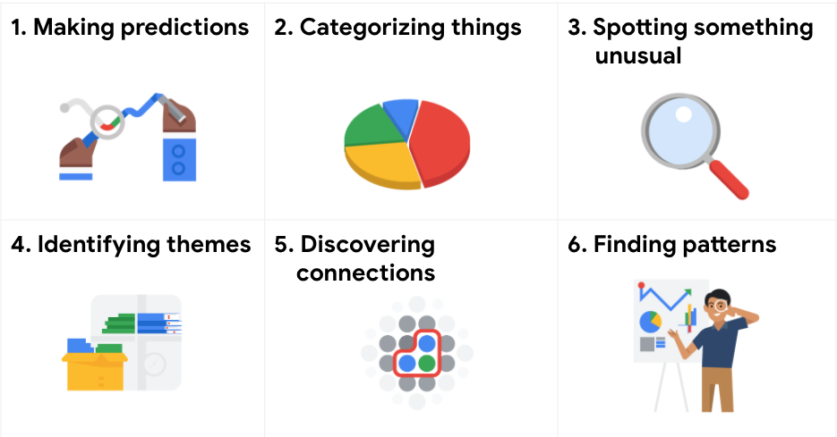1. Making predictions 2. Categorizing things 3. Spotting something unusual 4. Identifying themes 5. Discovering connections 6. Finding patterns

A video, [Common problem types](https://www.coursera.org/learn/ask-questions-make-decisions/lecture/E8HxZ/common-problem-types), introduced the six problem types with an example for each. The examples are summarized below for review.

### **Making predictions**

A company that wants to know the best advertising method to bring in new customers is an example of a problem requiring analysts to make predictions. Analysts with data on location, type of media, and number of new customers acquired as a result of past ads can't guarantee future results, but they can help predict the best placement of advertising to reach the target audience.

### **Categorizing things**

An example of a problem requiring analysts to categorize things is a company's goal to improve customer satisfaction. Analysts might classify customer service calls based on certain keywords or scores. This could help identify top-performing customer service representatives or help correlate certain actions taken with higher customer satisfaction scores.

### **Spotting something unusual**

A company that sells smart watches that help people monitor their health would be interested in designing their software to spot something unusual. Analysts who have analyzed aggregated health data can help product developers determine the right algorithms to spot and set off alarms when certain data doesn't trend normally.

### **Identifying themes**

User experience (UX) designers might rely on analysts to analyze user interaction data. Similar to problems that require analysts to categorize things, usability improvement projects might require analysts to identify themes to help prioritize the right product features for improvement. Themes are most often used to help researchers explore certain aspects of data. In a user study, user beliefs, practices, and needs are examples of themes.

By now you might be wondering if there is a difference between categorizing things and identifying themes. The best way to think about it is: categorizing things involves assigning items to categories; identifying themes takes those categories a step further by grouping them into broader themes.

### **Discovering connections**

A third-party logistics company working with another company to get shipments delivered to customers on time is a problem requiring analysts to discover connections. By analyzing the wait times at shipping hubs, analysts can determine the appropriate schedule changes to increase the number of on-time deliveries.

### **Finding patterns**

Minimizing downtime caused by machine failure is an example of a problem requiring analysts to find patterns in data. For example, by analyzing maintenance data, they might discover that most failures happen if regular maintenance is delayed by more than a 15-day window.

## Key takeaway

As you move through this program, you will develop a sharper eye for problems and you will practice thinking through the problem types when you begin your analysis. This method of problem solving will help you figure out solutions that meet the needs of all stakeholders.

You've been learning about six common problem types of data analysts encounter,

making predictions, categorizing things, spotting something unusual,

identifying themes, discovering connections, and finding patterns.

Let's think back to our real world example from a previous video.

In that example,

anywhere gaming repair wanted to figure out how to bring in new customers.

So the problem was, how to determine the best advertising method for

anywhere gaming repair's target audience.

To help solve this problem, the company used data to envision

what would happen if it advertised in different places.

Now nobody can see the future but the data helped them make an informed

decision about how things would likely work out.

So, their problem type was making predictions.

Now let's think about the second problem type, categorizing things.

Here's an example of a problem that involves categorization.

Let's say a business wants to improve its customer satisfaction levels.

Data analysts could review recorded calls to the company's customer

service department and evaluate the satisfaction levels of each caller.

They could identify certain key words or phrases that come up during

the phone calls and then assign them to categories such as politeness,

satisfaction, dissatisfaction, empathy, and more.

Categorizing these key words gives us data that lets the company

identify top performing customer service representatives, and

those who might need more coaching.

This leads to happier customers and higher customer service scores.

Okay, now let's talk about a problem that involves spotting something unusual.

Some of you may have a smart watch, my favorite app is for health tracking.

These apps can help people stay healthy by collecting data such as their heart rate,

sleep patterns, exercise routine, and much more.

There are many stories out there about health apps actually saving

people's lives.

One is about a woman who was young, athletic, and

had no previous medical problems.

One night she heard a beep on her smartwatch,

a notification said her heart rate had spiked.

Now in this example think of the watch as a data analyst.

The watch was collecting and analyzing health data.

So when her resting heart rate was suddenly 120 beats per minute,

the watch spotted something unusual because according to its data,

the rate was normally around 70.

Thanks to the data her smart watch gave her, the woman went to the hospital and

discovered she had a condition which could have led to life threatening

complications if she hadn't gotten medical help.

Now let's move on to the next type of problem: identifying themes.

We see a lot of examples of this in the user experience field.

User experience designers study and

work to improve the interactions people have with products they use every day.

Let's say a user experience designer wants to see what customers think about

the coffee maker his company manufactures.

This business collects anonymous survey data from users,

which can be used to answer this question.

But first to make sense of it all,

he will need to find themes that represent the most valuable data,

especially information he can use to make the user experience even better.

So the problem the user experience designer's company faces,

is how to improve the user experience for its coffee makers.

The process here is kind of like finding categories for

keywords and phrases in customer service conversations.

But identifying themes goes even further by grouping each insight into

a broader theme.

Then the designer can pinpoint the themes that are most common.

In this case he learned users often couldn't tell if the coffee maker

was on or off.

He ended up optimizing the design with improved placement and lighting for

the on/off button, leading to the product improvement and happier users.

Now we come to the problem of discovering connections.

This example is from the transportation industry and

uses something called third party logistics.

Third party logistics partners help businesses ship products when

they don't have their own trucks, planes or ships.

A common problem these partners face is figuring out how to reduce wait time.

Wait time happens when a truck driver from the third party logistics provider

arrives to pick up a shipment but it's not ready.

So she has to wait.

That costs both companies time and money and

it stops trucks from getting back on the road to make more deliveries.

So how can they solve this?

Well, by sharing data the partner companies can view each other's timelines

and see what's causing shipments to run late.

Then they can figure out how to avoid those problems in the future.

So a problem for one business doesn't cause a negative impact for the other.

For example, if shipments are running late because one company only delivers Mondays,

Wednesdays and Fridays, and the other company only delivers Tuesdays and

Thursdays, then the companies can choose to deliver on the same day to reduce

wait time for customers.

All right, we've come to our final problem type, finding patterns.

Oil and gas companies are constantly working to keep their machines running

properly.

So the problem is, how to stop machines from breaking down.

One way data analysts can do this is by looking at patterns

in the company's historical data.

For example, they could investigate how and when a particular machine

broke down in the past and then generate insights into what led to the breakage.

In this case, the company saw pattern indicating that machines began breaking

down at faster rates when maintenance wasn't kept up in 15 day cycles.

They can then keep track of current conditions and

intervene if any of these issues happen again.

Pretty cool, right?

I'm always amazed to hear about how data helps real people and

businesses make meaningful change.

I hope you are too.

See you soon.

A data analyst identifies and classifies keywords from customer reviews to improve customer satisfaction. This is an example of which problem type?

**1 / 1 point**



Categorizing things



Finding patterns



Making predictions



Spotting something unusual

**Correct**

A data analyst identifying and classifying keywords from customer reviews to improve customer satisfaction is an example of categorizing things.

### 2.

Question 2

The spotting something unusual problem type could involve which of the following scenarios?

**1 / 1 point**



A data insight helps a landscaping company envision what will happen in the future.



A data analyst working for an agricultural company examines why a dataset has a surprising and rare data point.



A data analyst at a clothing retailer creates a list of common topics, categorizes them, and groups each category into a broader subject area for further analysis.



A data analyst at an arts nonprofit classifies similar data points into groups for further analysis.

**Correct**

The problem type of spotting something unusual could involve a data analyst examining why a dataset has a surprising and rare data point. Spotting something unusual deals with identifying and analyzing something out of the ordinary.

### 3.

Question 3

A data analyst at an online retailer works with historical sales data. The analyst identifies repeating trends in the sales data. This is an example of which problem type?

**1 / 1 point**



Identifying themes



Making predictions



Finding patterns



Categorizing things

**Correct**

This is an example of finding patterns. Finding patterns deals with identifying trends in a data set.

We've talked a lot about what data

is and how it plays into decision-making.

What do we know already?

Well, we know that data is a collection of facts.

We also know that data analysis reveals

important patterns and insights about that data.

Finally, we know that data analysis

can help us make more informed decisions.

Now, we'll look at how data plays into

the decision-making process and take

a quick look at the differences between

data-driven and data-inspired decisions.

Let's look at a real-life example.

Think about the last time you

searched "restaurants near me" and

sorted the results by rating to

help you decide which one looks best.

That was a decision you made using data.

Businesses and other organizations use data

to make better decisions all the time.

There's two ways they can do this,

with data-driven or data-inspired decision-making.

We'll talk more about

data-inspired decision-making later on,

but here's a quick definition for now.

Data-inspired decision-making

explores different data sources

to find out what they have in common.

Here at Google, we use data every single day,

in very surprising ways too.

For example, we use data to help cut back on

the amount of energy spent cooling your data centers.

After analyzing years of

data collected with artificial intelligence,

we were able to make decisions

that help reduce the energy we

use to cool our data centers by over 40 percent.

Google's People Operations team

also uses data to improve how

we hire new Googlers

and how we get them started on the right foot.

We wanted to make sure we weren't

passing over any talented applicants and

that we made their transition into

their new roles as smooth as possible.

After analyzing data on applications, interviews,

and new hire orientation processes,

we started using an algorithm.

An algorithm is a process or set of

rules to be followed for a specific task.

With this algorithm, we reviewed applicants that didn't

pass the initial screening process

to find great candidates.

Data also helped us determine

the ideal number of interviews that lead to

the best possible hiring decisions.

We've created new onboarding agendas to

help new employees get started at their new jobs.

Data is everywhere.

Today, we create so much data that scientists estimate

90 percent of the world's data

has been created in just the last few years.

Think of the potential here.

The more data we have,

the bigger the problems we can solve and

the more powerful our solutions can be.

But responsibly gathering data

is only part of the process.

We also have to turn data into

knowledge that helps us make better solutions.

I'm going to let fellow Googler,

Ed, talk more about that.

Just having tons of data isn't enough.

We have to do something meaningful with it.

Data in itself provides little value.

To quote Jack Dorsey,

the founder of Twitter and Square,

"Every single action that we do in

this world is triggering off some amount of data,

and most of that data is meaningless until someone adds

some interpretation of it

or someone adds a narrative around it."

Data is straightforward, facts collected together,

values that describe something.

Individual data points become more

useful when they're collected and structured,

but they're still somewhat meaningless by themselves.

We need to interpret data to turn it into information.

Look at Michael Phelps' time in

a 200-meter individual medal swimming race,

one minute, 54 seconds.

Doesn't tell us much. When we

compare it to his competitor's times in the race,

however, we can see that Michael came

in the first place and won the gold medal.

Our analysis took data, in this case,

a list of Michael's races and times and turned it into

information by comparing it with other data.

Context is important.

We needed to know that this race was an Olympic final and

not some other random race to

determine that this was a gold medal finish.

But this still isn't knowledge.

When we consume information, understand it,

and apply it, that's when data is most useful.

In other words, Michael Phelps is a fast swimmer.

It's pretty cool how we can turn data into

knowledge that helps us in all kinds of ways,

whether it's finding the perfect restaurant or

making environmentally friendly changes.

But keep in mind,

there are limitations to data analytics.

Sometimes we don't have

access to all of the data we need,

or data is measured differently across programs,

which can make it difficult to find concrete examples.

We'll cover these more in detail later on,

but it's important that you start

thinking about them now.

Now that you know how data drives decision-making,

you know how key your role as

a data analyst is to the business.

Data is a powerful tool for decision-making,

and you can help provide businesses with the information

they need to solve problems and make new decisions,

but before that, you will

need to learn a little more about

the kinds of data you'll be

working with and how to deal with it.

We've talked a lot about what data

is and how it plays into decision-making.

What do we know already?

Well, we know that data is a collection of facts.

We also know that data analysis reveals

important patterns and insights about that data.

Finally, we know that data analysis

can help us make more informed decisions.

Now, we'll look at how data plays into

the decision-making process and take

a quick look at the differences between

data-driven and data-inspired decisions.

Let's look at a real-life example.

Think about the last time you

searched "restaurants near me" and

sorted the results by rating to

help you decide which one looks best.

That was a decision you made using data.

Businesses and other organizations use data

to make better decisions all the time.

There's two ways they can do this,

with data-driven or data-inspired decision-making.

We'll talk more about

data-inspired decision-making later on,

but here's a quick definition for now.

Data-inspired decision-making

explores different data sources

to find out what they have in common.

Here at Google, we use data every single day,

in very surprising ways too.

For example, we use data to help cut back on

the amount of energy spent cooling your data centers.

After analyzing years of

data collected with artificial intelligence,

we were able to make decisions

that help reduce the energy we

use to cool our data centers by over 40 percent.

Google's People Operations team

also uses data to improve how

we hire new Googlers

and how we get them started on the right foot.

We wanted to make sure we weren't

passing over any talented applicants and

that we made their transition into

their new roles as smooth as possible.

After analyzing data on applications, interviews,

and new hire orientation processes,

we started using an algorithm.

An algorithm is a process or set of

rules to be followed for a specific task.

With this algorithm, we reviewed applicants that didn't

pass the initial screening process

to find great candidates.

Data also helped us determine

the ideal number of interviews that lead to

the best possible hiring decisions.

We've created new onboarding agendas to

help new employees get started at their new jobs.

Data is everywhere.

Today, we create so much data that scientists estimate

90 percent of the world's data

has been created in just the last few years.

Think of the potential here.

The more data we have,

the bigger the problems we can solve and

the more powerful our solutions can be.

But responsibly gathering data

is only part of the process.

We also have to turn data into

knowledge that helps us make better solutions.

I'm going to let fellow Googler,

Ed, talk more about that.

Just having tons of data isn't enough.

We have to do something meaningful with it.

Data in itself provides little value.

To quote Jack Dorsey,

the founder of Twitter and Square,

"Every single action that we do in

this world is triggering off some amount of data,

and most of that data is meaningless until someone adds

some interpretation of it

or someone adds a narrative around it."

Data is straightforward, facts collected together,

values that describe something.

Individual data points become more

useful when they're collected and structured,

but they're still somewhat meaningless by themselves.

We need to interpret data to turn it into information.

Look at Michael Phelps' time in

a 200-meter individual medal swimming race,

one minute, 54 seconds.

Doesn't tell us much. When we

compare it to his competitor's times in the race,

however, we can see that Michael came

in the first place and won the gold medal.

Our analysis took data, in this case,

a list of Michael's races and times and turned it into

information by comparing it with other data.

Context is important.

We needed to know that this race was an Olympic final and

not some other random race to

determine that this was a gold medal finish.

But this still isn't knowledge.

When we consume information, understand it,

and apply it, that's when data is most useful.

In other words, Michael Phelps is a fast swimmer.

It's pretty cool how we can turn data into

knowledge that helps us in all kinds of ways,

whether it's finding the perfect restaurant or

making environmentally friendly changes.

But keep in mind,

there are limitations to data analytics.

Sometimes we don't have

access to all of the data we need,

or data is measured differently across programs,

which can make it difficult to find concrete examples.

We'll cover these more in detail later on,

but it's important that you start

thinking about them now.

Now that you know how data drives decision-making,

you know how key your role as

a data analyst is to the business.

Data is a powerful tool for decision-making,

and you can help provide businesses with the information

they need to solves and make new decisions,

but before that, you will

need to learn a little more about

the kinds of data you'll be

working with and how to deal with it.

Fill in the blank: Data-inspired decision-making explores different data sources to find \_\_\_\_\_.



problems



outliers



predictions



Commonalities THIS

Data trials and triumphs

This reading focuses on why accurate interpretation of data is key to data-driven decisions. You have been learning why data is such a powerful business tool and how data analysts help their companies make data-driven decisions for great results. As a quick reminder, the goal of all data analysts is to use data to draw accurate conclusions and make good recommendations. That all starts with having complete, correct, and relevant data.



But keep in mind, it is possible to have solid data and still make the wrong choices. It is up to data analysts to interpret the data accurately. **When data is interpreted incorrectly, it can lead to huge losses. Consider the examples below.**

**Coke launch failure**

In 1985, New Coke was launched, replacing the classic Coke formula. The company had done taste tests with 200,000 people and found that test subjects preferred the taste of New Coke over Pepsi, which had become a tough competitor. Based on this data alone, classic Coke was taken off the market and replaced with New Coke. This was seen as the solution to take back the market share that had been lost to Pepsi.

But as it turns out, New Coke was a massive flop and the company ended up losing tens of millions of dollars. How could this have happened with data that seemed correct? It is because the data wasn’t complete, which made it inaccurate. The data didn't consider how customers would feel about New Coke replacing classic Coke. The company’s decision to retire classic Coke was a data-driven decision based on incomplete data.

**Mars orbiter loss**

In 1999, NASA lost the $125 million Mars Climate Orbiter, even though it had good data. The spacecraft burned to pieces because of poor collaboration and communication. The Orbiter’s navigation team was using the **SI or metric system** (newtons) for their force calculations, but the engineers who built the spacecraft used the **English Engineering Units** **system** (pounds) for force calculations.

No one realized a problem even existed until the Orbiter burst into flames in the Martian atmosphere. Later, a NASA review board investigating the root cause of the problem figured out that the issue was isolated to the software that controlled the thrusters. One program calculated the thrusters’ force in pounds; another program looking at the data assumed it was in newtons. The software controllers were making data-driven decisions to adjust the thrust based on 100% accurate data, but these decisions were wrong because of inaccurate assumptions when interpreting it. A conversion of the data from one system of measurement to the other could have prevented the loss.



**When data is used strategically, businesses can transform and grow their revenue. Consider the examples below.**

**Crate and Barrel**

At Crate and Barrel, online sales jumped more than 40% during stay-at-home orders to combat the global pandemic. Currently, online sales make up more than 65% of their overall business. They are using data insights to accelerate their digital transformation and bring the best of online and offline experiences together for customers.

BigQuery enables Crate and Barrel to "draw on ten times [as many] information sources(compared to a few years ago) which are then analyzed and transformed into actionable insights that can be used to influence the customer’s next interaction. And this, in turn, drives revenue."

Read more about Crate and Barrel's data strategy in [How one retailer’s data strategy powers seamless customer experiences](https://www.thinkwithgoogle.com/future-of-marketing/digital-transformation/crate-and-barrel-digital-customer-experiences/).

**PepsiCo**

Since the days of the New Coke launch, things have changed dramatically for beverage and other consumer packaged goods (CPG) companies.

PepsiCo "hired analytical talent and established cross-functional workflows around an infrastructure designed to put consumers’ needs first. Then [they] set up the right processes to make critical decisions based on data and technology use cases. Finally, [they] invested in the right technology stack and platforms so that data could flow into a central cloud-based hub. This is critical. When data comes together, [they] develop a holistic understanding of the consumer and their journeys."

Read about how PepsiCo is delivering a more personal and valuable experience to customers using data in [How one of the world’s biggest marketers ripped up its playbook and learned to anticipate intent](https://www.thinkwithgoogle.com/marketing-strategies/data-and-measurement/pepsi-digital-transformation/).

**Key skills for triumphant results**

As a data analyst, your own skills and knowledge will be the most important part of any analysis project. It is important for you to keep a data-driven mindset, ask lots of questions, experiment with many different possibilities, and use both logic and creativity along the way. You will then be prepared to interpret your data with the highest levels of care and accuracy. Note that there is a difference between making a decision with incomplete data and making a decision with a small amount of data. You learned that making a decision with incomplete data is dangerous. But sometimes accurate data from a small test can help you make a good decision. Stay tuned. You will learn about how much data to collect later in the program.

Hi again.

When it comes to decision-making, data is key.

But we've also learned that

there are a lot of different kinds

of questions that data might help us answer,

and these different questions

make different kinds of data.

There are two kinds of data that we'll talk about in

this video, quantitative and qualitative.

Quantitative data is all about

the specific and objective measures of numerical facts.

This can often be the what,

how many, and how often about a problem.

In other words, things you can measure,

like how many commuters

take the train to work every week.

As a financial analyst,

I work with a lot of quantitative data.

I love the certainty and accuracy of numbers.

On the other hand,

qualitative data describes

subjective or explanatory measures of

qualities and characteristics or

things that can't be measured with numerical data,

like your hair color.

Qualitative data is great

for helping us answer why questions.

For example, why people might like

a certain celebrity or snack food more than others.

With quantitative data, we can see numbers

visualized as charts or graphs.

Qualitative data can then give us

a more high-level understanding of

why the numbers are the way they are.

This is important because it helps

us add context to a problem.

As a data analyst,

you'll be using both

quantitative and qualitative analysis,

depending on your business task.

Reviews are a great example of this.

Think about a time you used reviews to decide

whether you wanted to buy something or go somewhere.

These reviews might have told you

how many people dislike that thing and why.

Businesses read these reviews too,

but they use the data in different ways.

Let's look at an example of a business using data from

customer reviews to see

qualitative and quantitative data in action.

Now, say a local ice cream shop has started using

their online reviews to engage with

their customers and build their brand.

These reviews give the ice cream shop

insights into their customers' experiences,

which they can use to inform their decision-making.

The owner notices that their rating has been going down.

He sees that lately his shop

has been receiving more negative reviews.

He wants to know why,

so he starts asking questions.

First are measurable questions.

How many negative reviews are there?

What's the average rating?

How many of these reviews use the same keywords?

These questions generate quantitative data,

numerical results that help

confirm their customers aren't satisfied.

This data might lead them to ask different questions.

Why are customers unsatisfied?

How can we improve their experience?

These are questions that lead to qualitative data.

After looking through the reviews,

the ice cream shop owner sees a pattern,

17 of negative reviews use

the word "frustrated." That's quantitative data.

Now we can start collecting qualitative data

by asking why this word is being repeated?

He finds that customers are

frustrated because the shop is

running out of popular flavors before the end of the day.

Knowing this, the ice cream shop can change its

weekly order to make sure it has

enough of what the customers want.

With both quantitative and qualitative data,

the ice cream shop owner was able to figure out

his customers were unhappy and understand why.

Having both types of data made it possible for

him to make the right changes and improve his business.

Now that you know the difference between

quantitative and qualitative data,

you know how to get different types of

data by asking different questions.

It's your job as a data detective to know

which questions to ask to find the right solution.

Then you can start thinking

about cool and creative ways to

help stakeholders better understand the data.

For example, interactive dashboards,

which we'll learn about soon.

Hi again.

When it comes to decision-making, data is key.

But we've also learned that

there are a lot of different kinds

of questions that data might help us answer,

and these different questions

make different kinds of data.

There are two kinds of data that we'll talk about in

this video, quantitative and qualitative.

Quantitative data is all about

the specific and objective measures of numerical facts.

This can often be the what,

how many, and how often about a problem.

In other words, things you can measure,

like how many commuters

take the train to work every week.

As a financial analyst,

I work with a lot of quantitative data.

I love the certainty and accuracy of numbers.

On the other hand,

qualitative data describes

subjective or explanatory measures of

qualities and characteristics or

things that can't be measured with numerical data,

like your hair color.

Qualitative data is great

for helping us answer why questions.

For example, why people might like

a certain celebrity or snack food more than others.

With quantitative data, we can see numbers

visualized as charts or graphs.

Qualitative data can then give us

a more high-level understanding of

why the numbers are the way they are.

This is important because it helps

us add context to a problem.

As a data analyst,

you'll be using both

quantitative and qualitative analysis,

depending on your business task.

Reviews are a great example of this.

Think about a time you used reviews to decide

whether you wanted to buy something or go somewhere.

These reviews might have told you

how many people dislike that thing and why.

Businesses read these reviews too,

but they use the data in different ways.

Let's look at an example of a business using data from

customer reviews to see

qualitative and quantitative data in action.

Now, say a local ice cream shop has started using

their online reviews to engage with

their customers and build their brand.

These reviews give the ice cream shop

insights into their customers' experiences,

which they can use to inform their decision-making.

The owner notices that their rating has been going down.

He sees that lately his shop

has been receiving more negative reviews.

He wants to know why,

so he starts asking questions.

First are measurable questions.

How many negative reviews are there?

What's the average rating?

How many of these reviews use the same keywords?

These questions generate quantitative data,

numerical results that help

confirm their customers aren't satisfied.

This data might lead them to ask different questions.

Why are customers unsatisfied?

How can we improve their experience?

These are questions that lead to qualitative data.

After looking through the reviews,

the ice cream shop owner sees a pattern,

17 of negative reviews use

the word "frustrated." That's quantitative data.

Now we can start collecting qualitative data

by asking why this word is being repeated?

He finds that customers are

frustrated because the shop is

running out of popular flavors before the end of the day.

Knowing this, the ice cream shop can change its

weekly order to make sure it has

enough of what the customers want.

With both quantitative and qualitative data,

the ice cream shop owner was able to figure out

his customers were unhappy and understand why.

Having both types of data made it possible for

him to make the right changes and improve his business.

Now that you know the difference between

quantitative and qualitative data,

you know how to get different types of

data by asking different questions.

It's your job as a data detective to know

which questions to ask to find the right solution.

Then you can start thinking

about cool and creative ways to

help stakeholders better understand the data.

For example, interactive dashboards,

which we'll learn about soon.

Qualitative and quantitative data in business

This reading further elaborates on the meaning of **qualitative** versus **quantitative**.

As you have learned, there are two types of data: qualitative and quantitative.

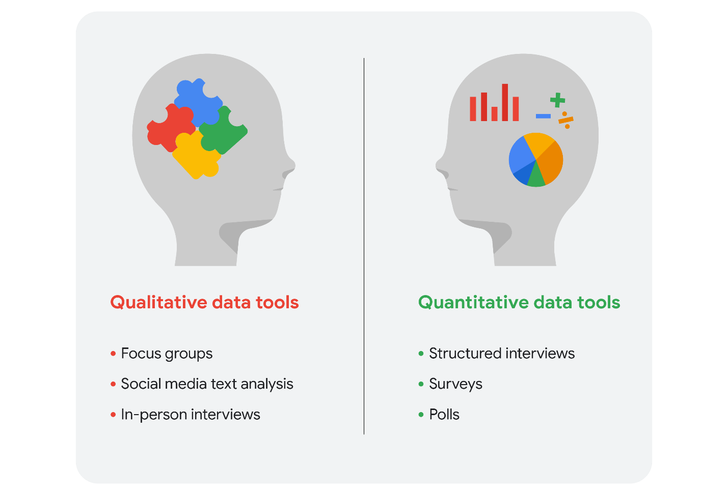Qualitative data tools: focus groups, social media text analysis, and in-person interviews Quantitative data tools: structured interviews, surveys, and polls

We can take a closer look at the data types and data collection tools. Imagine that you are a data analyst for a chain of movie theaters. Your manager wants you to track trends in:

* **Movie attendance over time**
* **Profitability of the concession stand**
* **Evening audience preferences**

In our scenario, we assume quantitative data already exists to monitor all three trends.

**Movie attendance over time**



Starting with the historical data the theater has through its loyalty and rewards program, your first step is to investigate what insights you can gain from that data. You look at attendance over the last 3 months. But, because the last 3 months didn’t include a major holiday, you decide it is better to look at a full year’s worth of data. As you suspected, the quantitative data confirmed that average attendance was 550 per month but then rose to an average of 1,600 per month for the months with holidays.

The historical data serves your needs for the project, but you also decide that you will resume the analysis again in a few months after the theater increases ticket prices for evening showtimes.

**Profitability of the concession stand**



Profit is calculated by subtracting cost from sales revenue. The historical data shows that while the concession stand was profitable, profit margins were razor thin at less than 5%. You saw that average purchases totaled $20 or less. You decide that you will keep monitoring this on an ongoing basis.

Based on your understanding of data collection tools, you will suggest an online survey of customers so they can comment on the food at the concession stand. This will enable you to gather even more quantitative data to revamp the menu and potentially increase profits.

**Evening audience preferences**



Your analysis of the historical data shows that the 7:30 PM showtime was the most popular and had the greatest attendance, followed by the 7:15 PM and 9:00 PM showtimes. You may suggest replacing the current 8:00 PM showtime that has lower attendance with an 8:30 PM showtime. But you need more data to back up your hunch that people would be more likely to attend the later show.

Evening movie-goers are the largest source of revenue for the theater. Therefore, you also decide to include a question in your online survey to gain more insight.

**Qualitative data for all three trends plus ticket pricing**

Since you know that the theater is planning to raise ticket prices for evening showtimes in a few months, you will also include a question in the survey to get an idea of customers’ price sensitivity.

Your final online survey might include these questions for qualitative data:

1. What went into your decision to see a movie in our theater today? (movie attendance)
2. What do you think about the quality and value of your purchases at the concession stand? (concession stand profitability)
3. Which showtime do you prefer, 8:00 PM or 8:30 PM, and why do you prefer that time? (evening movie-goer preferences)
4. Under what circumstances would you choose a matinee over a nighttime showing? (ticket price increase)

**Summing it up**

Data analysts will generally use both types of data in their work. Usually, qualitative data can help analysts better understand their quantitative data by providing a reason or more thorough explanation. In other words, quantitative data generally gives you the what, and qualitative data generally gives you the why. By using both quantitative and qualitative data, you can learn when people like to go to the movies and why they chose the theater. Maybe they really like the reclining chairs, so your manager can purchase more recliners. Maybe the theater is the only one that serves root beer. Maybe a later show time gives them more time to drive to the theater from where popular restaurants are located. Maybe they go to matinees because they have kids and want to save money. You wouldn’t have discovered this information by analyzing only the quantitative data for attendance, profit, and showtimes.

### 1.

Question 1

What is the difference between qualitative and quantitative data?

**1 / 1 point**



Qualitative data is about the quality of a product or service. Quantitative data is about how much of that product or service is available.



Qualitative data is specific. Quantitative data is subjective.



Qualitative data describes the kind of data being analyzed. Quantitative data describes how much data is being analyzed.



Qualitative data can be used to measure qualities and characteristics. Quantitative data can be used to measure numerical facts.

**Correct**

Qualitative data can be used to measure qualities and characteristics. Quantitative data can be used to measure numerical facts.

### 2.

Question 2

Fill in the blank: Data-inspired decision-making can discover \_\_\_\_\_ when exploring different data sources.

**1 / 1 point**



where the largest amount of data is



which experts can give advice



what the data has in common



if a decision was properly made

**Correct**

Data-inspired decision-making deals with exploring different data sources to discover what they have in common.

### 3.

Question 3

Which of the following examples describes using data to achieve business results? Select all that apply.

**0.5 / 1 point**



A video streaming service analyzes user preferences to customize movie recommendations.

**Correct**

Analyzing user preferences to customize movie recommendations and analyzing product purchases to create better promotions are examples of using data to achieve business results. These examples demonstrate putting analysis to work to achieve business results.



A movie theater tracks the number of weekend movie goers for three months.

**This should not be selected**

Analyzing user preferences to customize movie recommendations and analyzing product purchases to create better promotions are examples of using data to achieve business results. These examples demonstrate putting analysis to work to achieve business results.



A large retailer performs data analysis on product purchases to create better promotions.

**Correct**

Analyzing user preferences to customize movie recommendations and analyzing product purchases to create better promotions are examples of using data to achieve business results. These examples demonstrate putting analysis to work to achieve business results.



A grocery chain collects data on sale items and pricing from each store.

**This should not be selected**

Analyzing user preferences to customize movie recommendations and analyzing product purchases to create better promotions are examples of using data to achieve business results. These examples demonstrate putting analysis to work to achieve business results.

### 4.

Question 4

If someone is subjectively describing their feelings or emotions, it is qualitative data.

**1 / 1 point**



True



False

**Correct**

If someone is describing their feelings or emotions, they are providing qualitative data. Qualitative data is a subjective and explanatory measure of a quality or a characteristic.

Data is great, but if we

can't communicate the story data is telling,

it isn't useful to anyone.

We need ways to organize data that

help us turn it into information.

There are all kinds of tools out there to help you

visualize and share

your data analysis with stakeholders.

Here, we'll talk about

two data presentation tools, reports and dashboards.

Reports and dashboards are both

useful for data visualization.

But there are pros and cons for each of them.

A report is a static collection of

data given to stakeholders periodically.

A dashboard on the other hand,

monitors live, incoming data.

Let's talk about reports first.

Reports are great for giving snapshots of

high level historical data for an organization.

For example, a finance firm's monthly sales.

Reports come with a lot of benefits too.

They can be designed and sent out periodically,

often on a weekly or monthly basis,

as organized and easy to reference information.

They're quick to design and easy to

use as long as you continually maintain them.

Finally, because reports use static data or

data that doesn't change once it's been recorded,

they reflect data that's already been cleaned and sorted.

There are some downsides to keep in mind too.

Reports need regular maintenance

and aren't very visually appealing.

Because they aren't automatic or dynamic,

reports don't show live, evolving data.

For a live reflection of incoming data,

you'll want to design a dashboard.

Dashboards are great for a lot of reasons,

they give your team more access

to information being recorded,

you can interact through data by playing with filters,

and because they're dynamic,

they have long-term value.

If stakeholders need to continually access information,

a dashboard can be more efficient than

having to pull reports over and over,

which is a big time saver for you.

Last but not least,

they're just nice to look at.

But dashboards do have some cons too.

For one thing, they take a lot of time to design and

can actually be less efficient than reports,

if they're not used very often.

If the base table breaks at any point,

they need a lot of maintenance to

get back up and running again.

Dashboards can sometimes overwhelm

people with information too.

If you aren't used to

looking through data on a dashboard,

you might get lost in it.

As a data analyst,

you need to decide the best way to

communicate information to your stakeholders.

For example, what if your stakeholders are

interested in the company's social media engagement?

Would a monthly report that tells them

the number of new followers for their page be useful?

Or a dashboard that monitors live

social media engagement across multiple platforms?

Later on, you'll create

your own reports and

dashboards to practice using these tools.

But for now, I want to show you what

a report and a dashboard might look like.

We'll start by using a tool we're

already familiar with, spreadsheets.

Let's see one way

spreadsheet data could be visualized in a report.

This spreadsheet has a data set with

order details from a wholesale company.

That's a lot of information.

From the headers, we can see

different things recorded here,

like the order date,

the salesperson, the unit price,

and revenue for each transaction recorded.

It's all useful information,

but a little hard to wrap your head around.

We want a report that's easier to read.

Let's say your stakeholders want

a quick look at the revenue by salesperson.

Using the data, you could make them a pivot

table with a graph that shows that information.

A pivot table is

a data summarization tool

that is used in data processing.

Pivot tables are used to summarize, sort, re-organize,

group, count, total,

or average data stored in a database.

It allows its users to transform

columns into rows and rows into columns.

We'll actually learn more about pivot tables later.

But I'll show you one really quick.

We'll select the Data menu and click Pivot table button.

It can pull data from this table.

We can just press

create and it'll pull up a new worksheet.

Over here, it gives us

the pivot table fields we can choose from.

Click select, salesperson and revenue.

Just like that, it made a chart for us.

At this point, you can

play around with how the graph looks,

but the information is all there.

Let's move on to dashboards.

If you need a more dynamic way to

share information with your stakeholders,

dashboards are your friend.

You might create something like this Tableau dashboard.

With interactive graphs that

showcase multiple views of the data.

With this, users can change location, date range,

or any other aspect of the data they're viewing

by clicking through different elements on the dashboard.

Pretty cool, right?

Later in this program,

we'll look into how you can make

your own data visualizations.

We have a lot to learn before we get to that.

But I hope this was an exciting first peek at

the different visualization tools

you'll be using as a data analyst.

**The beauty of dashboards**

Dashboards are powerful visual tools that help you tell your data story. A **dashboard** organizes information from multiple datasets into one central location, offering huge time-savings. Data analysts use dashboards to track, analyze, and visualize data in order to answer questions and solve problems. For a basic idea of what dashboards look like, refer to this article: [6 real-world examples of business intelligence dashboards](https://www.tableau.com/learn/articles/business-intelligence-dashboards-examples). Tableau is one tool that is used to create dashboards and is covered later in the program.

The following table summarizes the benefits of using a dashboard for both data analysts and their stakeholders.

| **Benefits** | **For Data Analysts** | **For Stakeholders** |
| --- | --- | --- |
| **Centralization** | Sharing a single source of data with all stakeholders | Working with a comprehensive view of data, initiatives, objectives, projects, processes, and more |
| **Visualization** | Showing and updating live, incoming data in real time\* | Spotting changing trends and patterns more quickly |
| **Insightfulness** | Pulling relevant information from different datasets | Understanding the story behind the numbers to keep track of goals and make data-driven decisions |
| **Customization** | Creating custom views dedicated to a specific person, project, or presentation of the data | Drilling down to more specific areas of specialized interest or concern |

*\* It is important to remember that changed data is pulled into dashboards automatically only if the data structure is the same. If the data structure changes, you have to update the dashboard design before the data can update live.*

**Creating a dashboard**

Here is a process you can follow to create a dashboard:

**1.** **Identify the stakeholders who need to see the data and how they will use it**

To get started with this, you need to ask effective questions. Check out this [Requirements Gathering Worksheet](https://s3.amazonaws.com/looker-elearning-resources/Requirements+Gathering+Worksheet.pdf) to explore a wide range of good questions you can use to identify relevant stakeholders and their data needs. This is a great resource to help guide you through this process again and again.

**2. Design the dashboard (what should be displayed)**

Use these tips to help make your dashboard design clear, easy to follow, and simple:

* Use a clear header to label the information
* Add short text descriptions to each visualization
* Show the most important information at the top

**3. Create mock-ups if desired**

This is optional, but a lot of data analysts like to sketch out their dashboards before creating them.

**4. Select the visualizations you will use on the dashboard**

You have a lot of options here and it all depends on what data story you are telling. If you need to show a change of values over time, line charts or bar graphs might be the best choice. If your goal is to show how each part contributes to the whole amount being reported, a pie or donut chart is probably a better choice.

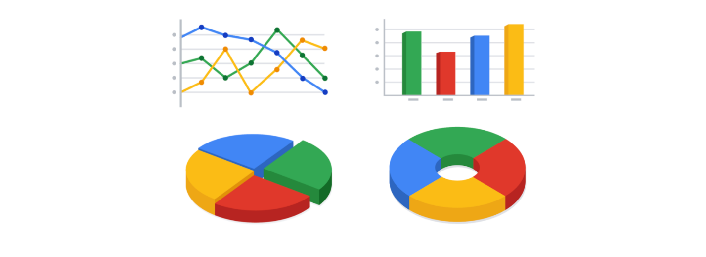

To learn more about choosing the right visualizations, check out Tableau’s galleries:

* For more samples of area charts, column charts, and other visualizations, visit [Tableau’s Viz Gallery](https://www.tableau.com/solutions/gallery). This gallery is full of great examples that were created using real data; explore this resource on your own to get some inspiration.
* Explore [Tableau’s Viz of the Day](https://public.tableau.com/en-us/gallery/?tab=viz-of-the-day&type=viz-of-the-day) to see visualizations curated by the community. These are visualizations created by Tableau users and are a great way to learn more about how other data analysts are using data visualization tools.

**5.** **Create filters as needed**

Filters show certain data while hiding the rest of the data in a dashboard. This can be a big help to identify patterns while keeping the original data intact. It is common for data analysts to use and share the same dashboard, but manage their part of it with a filter. To dig deeper into filters and find an example of filters in action, you can visit Tableau’s page on [Filter Actions](https://help.tableau.com/current/pro/desktop/en-us/actions_filter.htm). This is a useful resource to save and come back to when you start practicing using filters in Tableau on your own.

**Dashboards are part of a business journey**

Just like how the dashboard on an airplane shows the pilot their flight path, your dashboard does the same for your stakeholders. It helps them navigate the path of the project inside the data. If you add clear markers and highlight important points on your dashboard, users will understand where your data story is headed. Then, you can work together to make sure the business gets where it needs to go.

Question 1

Fill in the blank: Pivot tables in data processing tools are used to \_\_\_\_\_ data.

**1 / 1 point**



validate



summarize



clean



populate

**Correct**

Pivot tables are used to summarize data.

### 2.

Question 2

In data analytics, how are dashboards different from reports?

**1 / 1 point**



Dashboards are used to share updates with stakeholders only periodically. Reports give stakeholders continuous access to data.



Dashboards provide a high-level presentation of historical data. Reports provide a more detailed presentation of live, interactive data.



Dashboards contain static data. Reports contain data that is constantly changing.



Dashboards monitor live, incoming data from multiple datasets and organize the information into one central location. Reports are static collections of data.

**Correct**

Dashboards monitor live, incoming data from multiple datasets and organize the information into one central location. Reports are static collections of data.

### 3.

Question 3

Describe the difference between data and metrics.

**1 / 1 point**



Data is a collection of facts. Metrics are quantifiable data types used for measurement.



Data is quantifiable and used for measurement. Metrics are unorganized collections of facts.



Data is quantifiable. Metrics are unquantifiable.



Data can be used for measurement. Metrics cannot be used for measurement.

**Correct**

Data is a collection of facts. Metrics are quantifiable data types used for measurement.

### 4.

Question 4

Return on Investment (ROI) uses which of the following metrics in its definition?

**1 / 1 point**



Supply and demand



Profit and investment



Inventory and units



Sales and margin

**Correct**

Return on Investment (ROI) = Profit/Investment.

So far, you've learned a lot about how to think like a data analyst.

We've explored a few different ways of thinking.

And now, I want to take that one step further by using a mathematical approach

to problem-solving.

Mathematical thinking is a powerful skill you can use to help you solve problems and

see new solutions.

So, let's take some time to talk about what mathematical thinking is, and

how you can start using it.

Using a mathematical approach doesn't mean you have to suddenly become a math whiz.

It means looking at a problem and logically breaking it down step-by-step,

so you can see the relationship of patterns in your data, and

use that to analyze your problem.

This kind of thinking can also help you figure out the best tools for analysis

because it lets us see the different aspects of a problem and

choose the best logical approach.

There are a lot of factors to consider when choosing the most helpful tool for

your analysis.

One way you could decide which tool to use is by the size of your dataset.

When working with data, you'll find that there's big and small data.

Small data can be really small.

These kinds of data tend to be made up of datasets concerned with specific

metrics over a short, well defined period of time.

Like how much water you drink in a day.

Small data can be useful for making day-to-day decisions,

like deciding to drink more water.

But it doesn't have a huge impact on bigger frameworks like business

operations.

You might use spreadsheets to organize and

analyze smaller datasets when you first start out.

Big data on the other hand has larger,

less specific datasets covering a longer period of time.

They usually have to be broken down to be analyzed.

Big data is useful for looking at large- scale questions and problems, and

they help companies make big decisions.

When you're working with data on this larger scale, you might switch to SQL.

Let's look at an example of how a data analyst working in a hospital might use

mathematical thinking to solve a problem with the right tools.

The hospital might find that they're having a problem with over or

under use of their beds.

Based on that, the hospital could make bed optimization a goal.

They want to make sure that beds are available to patients who need them, but

not waste hospital resources like space or money on maintaining empty beds.

Using mathematical thinking, you can break this problem down into a step-by-step

process to help you find patterns in their data.

There's a lot of variables in this scenario.

But for now, let's keep it simple and focus on just a few key ones.

There are metrics that are related to this problem that might show us patterns in

the data:

for example, maybe the number of beds open and

the number of beds used over a period of time.

There's actually already a formula for this.

It's called the bed occupancy rate, and

it's calculated using the total number of inpatient days, and

the total number of available beds over a given period of time.

What we want to do now is take our key variables and see how their relationship

to each other might show us patterns that can help the hospital make a decision.

To do that, we have to choose the tool that makes sense for this task.

Hospitals generate a lot of patient data over a long period of time.

So logically, a tool that's capable of handling big datasets is a must.

SQL is a great choice.

In this case, you discover that the hospital always has unused beds.

Knowing that, they can choose to get rid of some beds, which saves them space and

money that they can use to buy and store protective equipment.

By considering all of the individual parts of this problem logically,

mathematical thinking helped us see new perspectives that led us to a solution.

Well, that's it for now.

Great job.

You've covered a lot of material already.

You've learned about how empowering data can be in decision-making,

the difference between quantitative and qualitative analysis,

using reports and dashboards for data visualization,

metrics, and using a mathematical approach to problem-solving.

Coming up next, we'll be tackling spreadsheet basics.

You'll get to put what you've learned into action and

learn a new tool to help you along the data analysis process.

See you soon.

Big and small data

As a data analyst, you will work with data both big and small. Both kinds of data are valuable, but they play very different roles.



Whether you work with big or small data, you can use it to help stakeholders improve business processes, answer questions, create new products, and much more. But there are certain challenges and benefits that come with big data and the following table explores the differences between big and small data.

| **Small data** | **Big data** |
| --- | --- |
| Describes a data set made up of specific metrics over a short, well-defined time period | Describes large, less-specific data sets that cover a long time period |
| Usually organized and analyzed in spreadsheets | Usually kept in a database and queried |
| Likely to be used by small and midsize businesses | Likely to be used by large organizations |
| Simple to collect, store, manage, sort, and visually represent | Takes a lot of effort to collect, store, manage, sort, and visually represent |
| Usually already a manageable size for analysis | Usually needs to be broken into smaller pieces in order to be organized and analyzed effectively for decision-making |

**Challenges and benefits**

Here are some **challenges** you might face when working with big data:

* A lot of organizations deal with data overload and way too much unimportant or irrelevant information.
* Important data can be hidden deep down with all of the non-important data, which makes it harder to find and use. This can lead to slower and more inefficient decision-making time frames.
* The data you need isn’t always easily accessible.
* Current technology tools and solutions still struggle to provide measurable and reportable data. This can lead to unfair algorithmic bias.
* There are gaps in many big data business solutions.

Now for the good news! Here are some **benefits** that come with big data:

* When large amounts of data can be stored and analyzed, it can help companies identify more efficient ways of doing business and save a lot of time and money.
* Big data helps organizations spot the trends of customer buying patterns and satisfaction levels, which can help them create new products and solutions that will make customers happy.
* By analyzing big data, businesses get a much better understanding of current market conditions, which can help them stay ahead of the competition.
* As in our earlier social media example, big data helps companies keep track of their online presence—especially feedback, both good and bad, from customers. This gives them the information they need to improve and protect their brand.

**The three (or four) V words for big data**

When thinking about the benefits and challenges of big data, it helps to think about the three Vs: **volume, variety,** and **velocity.** Volume describes the amount of data. Variety describes the different kinds of data. Velocity describes how fast the data can be processed. Some data analysts also consider a fourth V: **veracity.** Veracity refers to the quality and reliability of the data. These are all important considerations related to processing huge, complex data sets.

| **Volume** | **Variety** | **Velocity** | **Veracity** |
| --- | --- | --- | --- |
| The amount of data | The different kinds of data | How fast the data can be processed | The quality and reliability of the data |

Describe the key differences between small data and big data. Select all that apply.

**1 / 1 point**



Small data involves datasets concerned with a small number of specific metrics. Big data involves datasets that are larger and less specific.

**Correct**

Small data involves a small number of specific metrics over a shorter period of time. It’s effective for analyzing day-to-day decisions. Big data involves larger and less specific datasets and focuses on change over a long period of time. It’s effective for analyzing more substantial decisions.



Small data is typically stored in a database. Big data is typically stored in a spreadsheet.



Small data is effective for analyzing day-to-day decisions. Big data is effective for analyzing more substantial decisions.

**Correct**

Small data involves a small number of specific metrics over a shorter period of time. It’s effective for analyzing day-to-day decisions. Big data involves larger and less specific datasets and focuses on change over a long period of time. It’s effective for analyzing more substantial decisions.



Small data focuses on short, well-defined time periods. Big data focuses on change over a long period of time.

**Correct**

Small data involves a small number of specific metrics over a shorter period of time. It’s effective for analyzing day-to-day decisions. Big data involves larger and less specific datasets and focuses on change over a long period of time. It’s effective for analyzing more substantial decisions.

### 2.

Question 2

Which of the following is an example of small data?

**1 / 1 point**



The total absences of all high school students



The number of steps someone walks in a day



The bed occupancy rate for a hospital for the past decade



The trade deficit between two countries over a hundred years

**Correct**

The number of steps someone walks in a day is an example of small data.

### 3.

Question 3

The amount of exercise time it takes for a single person to burn a minimum of 400 calories is a problem that requires big data.

**1 / 1 point**



True



False

**Correct**

This problem can be solved using small data. It contains a specific metric (400 calories) and a short, defined period of time (amount of exercise time).

### 1.

Question 1

In data analytics, a pattern is defined as a process or set of rules to be followed for a specific task.

**1 / 1 point**



True



False

**Correct**

In data analytics, an algorithm is defined as a process or set of rules to be followed for a specific task.

### 2.

Question 2

Fill in the blank: If a data analyst is measuring qualities and characteristics, they are considering \_\_\_\_\_ data.

**1 / 1 point**



quantitative



cleaned



qualitative



unbiased

**Correct**

If a data analyst is measuring qualities and characteristics, they are considering qualitative data.

### 3.

Question 3

In data analytics, dashboards monitor data that is a continuous source of incoming information. Which of the following terms describes this type of data?

**1 / 1 point**



Sorted



Comprehensive



Live



Filtered

**Correct**

Live data is a continuous source of incoming information.

### 4.

Question 4

Which data-summarization tool do data analysts use to sort, reorganize, group, count, total, or average data?

**1 / 1 point**



A pivot table



A report



A function



A dashboard

**Correct**

To sort, reorganize, group, count, total or average data, data analysts use a pivot table.

### 5.

Question 5

A metric is a specific type of data that companies use to identify a problem domain.

**1 / 1 point**



True



False

**Correct**

A metric is a single, quantifiable type of data used when setting and evaluating goals.

### 6.

Question 6

Fill in the blank: A metric goal is a \_\_\_\_\_ goal set by a company that is evaluated using metrics.

**1 / 1 point**



conceptual



finite



measurable



theoretical

**Correct**

A metric goal is a measurable goal set by a company that is evaluated using metrics.

### 7.

Question 7

If a data analyst compares the cost of an investment to the net profit of that investment over a period of time, they’re analyzing the investment scope.

**1 / 1 point**



True



False

**Correct**

If a data analyst compares the cost of an investment to the net profit of that investment over a period of time, they’re analyzing the return on investment.

### 8.

Question 8

Describe the main differences between big and small data.

**1 / 1 point**



Small data is typically stored and organized in databases. Big data is typically stored and organized in spreadsheets.



Small data has been cleaned and sorted. Big data has not yet been cleaned or sorted.



Small data is less useful to data analysts. Big data is more useful to data analysts.



Small data is specific and concerns a short time period. Big data is less specific and concerns a longer time period.

**Correct**

Small data is specific and concerns a short time period. Big data is less specific and concerns a longer time period.

ata scenarios and responses

Being able to communicate in multiple formats is a key skill for data analysts. Listening, speaking, presenting, and writing skills will help you succeed in your projects and in your career. This reading covers effective communication strategies, including examples of clearly worded emails for common situations.

Here's an important first tip: Know your audience! When you communicate your analysis and recommendations as a data analyst, it's vital to keep your audience in mind.

Be sure to answer these four important questions related to your audience:

1. **Who is your audience?**
2. **What do they already know?**
3. **What do they need to know?**
4. **How can you best communicate what they need to know?**

**Project example**

As a data analyst, you'll get plenty of requests and questions through email. Let’s walk through an example of how you might approach answering one of these emails. Assume you're a data analyst working at a company that develops mobile apps. Let's start by reviewing answers to the four audience questions we just covered:



Kiri, Product Development Project Manager



Kiri received updates about our project from its planning stages, including the most recent project report**,** sent two weeks ago.



Kiri needs an update on the analysis project’s progress and needs to know that the executive team approved changes to the data and timeline. You know that adding a new variable to the analysis will impact the current project timeline. Kiri will need to change the project’s milestones and completion date.



You can start by sending an email update to Kiri with the latest timeline for the project, but a meeting might be necessary if she wants to talk through her concerns about missing a deadline.

**Updated timeline email sample**

After answering the audience questions, you have the key building blocks you need to write an email to Kiri. Here's an example of how these questions can help organize the flow of the email message:

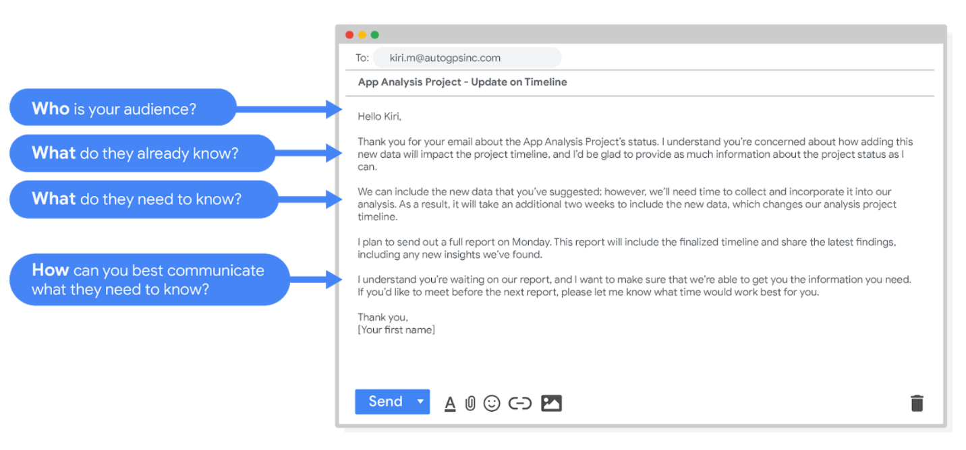Hello Kiri, (who is your audience?) Thank you for your email about the app analysis project's status. I understand you're concerned about how adding this new data will impact the project timeline, and I'd be glad to provide as much information about the project status as I can. (What do they already know? ) We can include the new data that you've suggested however, we'll need time to collect and incorporate it into our analysis. As a result, it will take an additional two weeks to include the new data, which changes our analysis project timeline. (What do they need to know?) I plan to send out a full report on Monday. This report will include the finalized timeline and share the latest findings, including any new insights we've found. I understand you're waiting on our report, and I want to make sure that we're able to get you the information you need. If you'd like to meet before the next report, please let me know what time would work best for you. (How can you best communicate what they need to know?) Thank you, (your first name)

After receiving your email, Kiri will have a clearer view of the changes to the analysis project and will be able to make adjustments to work with the new timeline.

**Project follow-up email sample**

After the next report is completed, you can also send out a project update offering more information. The email could look like this:

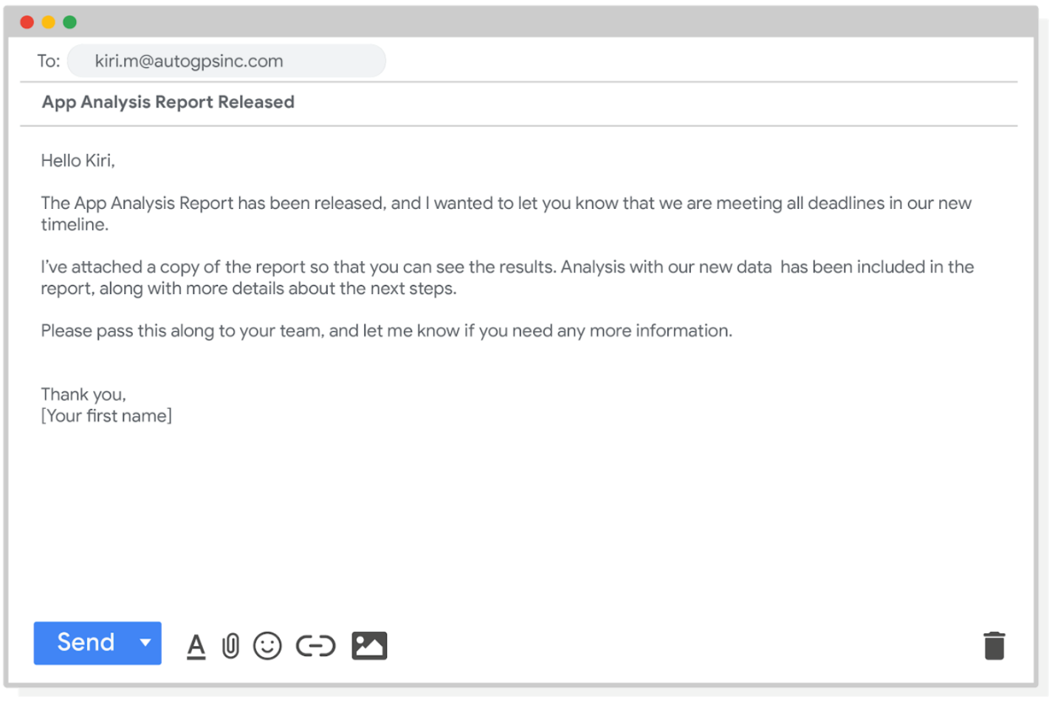Hello Kiri, The app analysis report has been released, and I wanted to let you know that we are meeting all deadlines in our new timeline. I've attached a copy of the report so that you can see the results. Analysis with our new data has been included in the report, along with more details about the next steps. Please pass this along to your team, and let me know if you need any more information. Thank you, [your first name]

Good communication keeps stakeholders updated on progress and ultimately helps prevent problems. Carefully worded responses are key. Whether you gather and address feedback using email, meetings, or reports, everyone you work with will know what to expect. As a result, they will be able to better manage their own schedules, resources, and teams.

# Limitations of data

Data is powerful, but it has its limitations. Has someone’s personal opinion found its way into the numbers? Is your data telling the whole story? Part of being a great data analyst is knowing the limits of data and planning for them. This reading explores how you can do that.



If you have incomplete or nonexistent data, you might realize during an analysis that you don't have enough data to reach a conclusion. Or, you might even be solving a different problem altogether! For example, suppose you are looking for employees who earned a particular certificate but discover that certification records go back only two years at your company. You can still use the data, but you will need to make the limits of your analysis clear. You might be able to find an alternate source of the data by contacting the company that led the training. But to be safe, you should be up front about the incomplete dataset until that data becomes available.



If you're collecting data from other teams and using existing spreadsheets, it is good to keep in mind that people use different business rules. So one team might define and measure things in a completely different way than another. For example, if a metric is the total number of trainees in a certificate program, you could have one team that counts every person who registered for the training, and another team that counts only the people who completed the program. In cases like these, establishing how to measure things early on standardizes the data across the board for greater reliability and accuracy. This will make sure comparisons between teams are meaningful and insightful.



Dirty data refers to data that contains errors. Dirty data can lead to productivity loss, unnecessary spending, and unwise decision-making. A good data cleaning effort can help you avoid this. As a quick reminder, data cleaning is the process of fixing or removing incorrect, corrupted, incorrectly formatted, duplicate, or incomplete data within a dataset. When you find and fix the errors - while tracking the changes you made - you can avoid a data disaster. You will learn how to clean data later in the training.



Avinash Kaushik, a Digital Marketing Evangelist for Google, has lots of great tips for data analysts in his [blog: Occam's Razor](http://www.kaushik.net/). Below are some of the best practices he recommends for good data storytelling:

* **Compare the same types of data**: Data can get mixed up when you chart it for visualization. Be sure to compare the same types of data and double check that any segments in your chart definitely display different metrics.
* **Visualize with care**: A 0.01% drop in a score can look huge if you zoom in close enough. To make sure your audience sees the full story clearly, it is a good idea to set your Y-axis to 0.
* **Leave out needless graphs:** If a table can show your story at a glance, stick with the table instead of a pie chart or a graph. Your busy audience will appreciate the clarity.
* **Test for statistical significance:** Sometimes two datasets will look different, but you will need a way to test whether the difference is real and important. So remember to run statistical tests to see how much confidence you can place in that difference.
* **Pay attention to sample size**: Gather lots of data. If a sample size is small, a few unusual responses can skew the results. If you find that you have too little data, be careful about using it to form judgments. Look for opportunities to collect more data, then chart those trends over longer periods.



In any organization, a big part of a data analyst’s role is making sound judgments. When you know the limitations of your data, you can make judgment calls that help people make better decisions supported by the data. Data is an extremely powerful tool for decision-making, but if it is incomplete, misaligned, or hasn’t been cleaned, then it can be misleading. Take the necessary steps to make sure that your data is complete and consistent. Clean the data before you begin your analysis to save yourself and possibly others a great amount of time and effort.

### 1.

Question 1

To communicate clearly with stakeholders and team members, there are four key questions data analysts ask themselves. The first is: Who is my audience? Identify the remaining three questions. Select all that apply.

**1 / 1 point**



How can I communicate effectively to my audience?

**Correct**

The four key questions data analysts ask themselves when communicating with stakeholders are: Who is my audience? What do they already know? What do they need to know? And how can I communicate effectively with them?



What does my audience need to know?

**Correct**

The four key questions data analysts ask themselves when communicating with stakeholders are: Who is my audience? What do they already know? What do they need to know? And how can I communicate effectively with them?



Why are stakeholders and team members important?



What does my audience already know?

**Correct**

The four key questions data analysts ask themselves when communicating with stakeholders are: Who is my audience? What do they already know? What do they need to know? And how can I communicate effectively with them?

### 2.

Question 2

A colleague sent you a question via email nearly two days ago. You know it’s going to take a while for you to find the answer because you need to do some research first. You’re too busy to get it done today. What’s the best course of action?

**1 / 1 point**



Forward the email to the entire data analytics team, and ask if someone else can answer the question for you.



Reply with a quick update thanking the sender for their patience and letting them know when they can expect you to respond with the answer to their question.



Delete the email. By the time you’re able to answer the question, it won’t be helpful information anyway.



Respond right away with your best guess to the answer of their question. The sender has been waiting nearly 48 hours, and any response is better than nothing.

**Correct**

The best course of action is to reply with a quick update thanking the sender for their patience and letting them know when they can expect you to respond with the answer to their question.

### 3.

Question 3

Focusing on stakeholder expectations enables data analysts to achieve what goals? Select all that apply.

**1 / 1 point**



Multitask more effectively



Understand project goals

**Correct**

Focusing on stakeholder expectations enables data analysts to understand project goals, improve communication, and build trust.



Build trust

**Correct**

Focusing on stakeholder expectations enables data analysts to understand project goals, improve communication, and build trust.



Improve communication among teams

**Correct**

Focusing on stakeholder expectations enables data analysts to understand project goals, improve communication, and build trust.

### 4.

Question 4

A stakeholder has asked a data analyst to produce a report very quickly. What are some strategies the analyst can apply to ensure their work isn’t rushed, answers the right question, and delivers useful results? Select all that apply.

**1 / 1 point**



Work overtime to get the report done by the following day



Outline the problem

**Correct**

To ensure their work answers the right questions and delivers useful results, the data analyst should set clear expectations, outline the problem, and reframe the question.



Set clear expectations about timeframe

**Correct**

To ensure their work answers the right questions and delivers useful results, the data analyst should set clear expectations, outline the problem, and reframe the question.



Reframe the question

**Correct**

To ensure their work answers the right questions and delivers useful results, the data analyst should set clear expectations, outline the problem, and reframe the question.

### 5.

Question 5

Asking questions including, “Does my analysis answer the original question?” and “Are there other angles I haven’t considered?” enable data analysts to accomplish what tasks? Select all that apply.

**0.5 / 1 point**



Consider the best ways to share data with others



Identify primary and secondary stakeholders

**This should not be selected**

Asking questions such as these enables data analysts to consider the best ways to share data with others, help their team make informed decisions, and use data to get to a solid conclusion.



Help their team make informed, data-driven decisions

**Correct**

Asking questions such as these enables data analysts to consider the best ways to share data with others, help their team make informed decisions, and use data to get to a solid conclusion.



Use data to get to a solid conclusion

**Correct**

Asking questions such as these enables data analysts to consider the best ways to share data with others, help their team make informed decisions, and use data to get to a solid conclusion.

### 1.

Question 1

**Scenario 1, questions 1-5**

You’ve just started a job as a data analyst at a small software company that provides data analytics and business intelligence solutions. Your supervisor asks you to kick off a project with a new client, Athena’s Story, a feminist bookstore. They have four existing locations, and the fifth shop has just opened in your community.

Athena’s Story wants to produce a campaign to generate excitement for an upcoming celebration and introduce the bookstore to the community. They share some data with your team to help make the event as successful as possible.

Your task is to review the assignment and the available data, then present your approach to your supervisor. Click the link below to access the email from your supervisor:

**[Course 2 Scenario 1 Email from Supervisor.pdf](https://d3c33hcgiwev3.cloudfront.net/2yakQO9XTwGmpEDvV68B4Q_f7d0d0209b994dcf9edb8f52258238b3_Course-2-Scenario-1-Email-from-Supervisor.pdf?Expires=1679529600&Signature=LE8RzlbFXh-Dm4olYUNasZfNUuuxaLZy69tyg0o9IaA7Ns8Z5HUWYqI5yjnju5vr4iMuFLRAgrT3Cl3SCzui8-9CFuHQzWa3orW6lI5XjjWWI4mOrLnax1dNcl-LowN7sfF3oO6N3v8KvXUtCJziVTlpZZPiy8ASewuyv5jc7CM_&Key-Pair-Id=APKAJLTNE6QMUY6HBC5A" \t "_blank)**

[PDF File](https://d3c33hcgiwev3.cloudfront.net/2yakQO9XTwGmpEDvV68B4Q_f7d0d0209b994dcf9edb8f52258238b3_Course-2-Scenario-1-Email-from-Supervisor.pdf?Expires=1679529600&Signature=LE8RzlbFXh-Dm4olYUNasZfNUuuxaLZy69tyg0o9IaA7Ns8Z5HUWYqI5yjnju5vr4iMuFLRAgrT3Cl3SCzui8-9CFuHQzWa3orW6lI5XjjWWI4mOrLnax1dNcl-LowN7sfF3oO6N3v8KvXUtCJziVTlpZZPiy8ASewuyv5jc7CM_&Key-Pair-Id=APKAJLTNE6QMUY6HBC5A" \t "_blank)



Then, review the email, and the Customer Survey and Historical Sales datasets.

To use the templates for the datasets, click the links below and select “Use Template.”

Links to templates: [Customer Survey](https://docs.google.com/spreadsheets/d/1HbBfNTuHCmQyY0GJrsdj6OCOkmeA5sUAQ-jXx8bMdpY/template/preview) and [Historical Sales](https://docs.google.com/spreadsheets/d/1HO8B-svc3Mmm3hlWycvX61Boxl9RQv6nKKWnkRig83E/template/preview)

OR

If you don't have a Google account, you can download the CSV files directly from the attachments below.

**[CustomerSurvey - CustomerSurvey](https://d3c33hcgiwev3.cloudfront.net/_LXSUq69QW-10lKuvXFv5Q_481077a5912c487eb76e0e2c74bccce9_CustomerSurvey---CustomerSurvey.csv?Expires=1679529600&Signature=JnJzEF0eg2PztpTP9jt77ye~gsE7Ywst3T~odjr-~jVgcCZEQg5X5sXz-qLy50gD0gdLyq~ahsIA5XEYLKw2ji4dOjBmQjRQ2tMtEbau7MjH9ehP2dJkED93LnvMRnmp5sNBkzCBjVp6rGEu5loxrWGgOqk0D9Lwx1vuJSuj96o_&Key-Pair-Id=APKAJLTNE6QMUY6HBC5A" \t "_blank)**

[CSV File](https://d3c33hcgiwev3.cloudfront.net/_LXSUq69QW-10lKuvXFv5Q_481077a5912c487eb76e0e2c74bccce9_CustomerSurvey---CustomerSurvey.csv?Expires=1679529600&Signature=JnJzEF0eg2PztpTP9jt77ye~gsE7Ywst3T~odjr-~jVgcCZEQg5X5sXz-qLy50gD0gdLyq~ahsIA5XEYLKw2ji4dOjBmQjRQ2tMtEbau7MjH9ehP2dJkED93LnvMRnmp5sNBkzCBjVp6rGEu5loxrWGgOqk0D9Lwx1vuJSuj96o_&Key-Pair-Id=APKAJLTNE6QMUY6HBC5A" \t "_blank)

**[HistoricalSales - HistoricalSales](https://d3c33hcgiwev3.cloudfront.net/pgHcQsMpSimB3ELDKRop2w_14ece9a7ea494ad38be47428779bb28b_HistoricalSales---HistoricalSales.csv?Expires=1679529600&Signature=U3YDOW5as8XkNV5Cm6oCqLCGJrpn98tz5IcX4FFzZUOEeGrpVLMkiV~cQaoESEJgKOKpcnuTOoZgjYn6t-KZgr6o3wkHTHBP~x6gwYyIBn4TrGP~A2Ht8CDIfFrTFuSLWbiF~BZah6UOy6dc0na-r7VVDqQ7uu64WdWeCcHsQ4Q_&Key-Pair-Id=APKAJLTNE6QMUY6HBC5A" \t "_blank)**

[CSV File](https://d3c33hcgiwev3.cloudfront.net/pgHcQsMpSimB3ELDKRop2w_14ece9a7ea494ad38be47428779bb28b_HistoricalSales---HistoricalSales.csv?Expires=1679529600&Signature=U3YDOW5as8XkNV5Cm6oCqLCGJrpn98tz5IcX4FFzZUOEeGrpVLMkiV~cQaoESEJgKOKpcnuTOoZgjYn6t-KZgr6o3wkHTHBP~x6gwYyIBn4TrGP~A2Ht8CDIfFrTFuSLWbiF~BZah6UOy6dc0na-r7VVDqQ7uu64WdWeCcHsQ4Q_&Key-Pair-Id=APKAJLTNE6QMUY6HBC5A" \t "_blank)



After reading the email, you notice that the acronym WHM appears in multiple places. You look it up online, and the most common result is web host manager. That doesn’t seem right to you, as it doesn’t fit the context of a feminist bookstore. You email your supervisor to ask. **When writing your email, what do you do to ensure it sounds professional? Select all that apply.**

**0.75 / 1 point**



Use a polite greeting and closing.

**Correct**

Professional emails use a polite greeting and closing, are free of typos, and are concise.



Respect your supervisor’s time by writing an email that’s short and to the point.

**Correct**

Professional emails use a polite greeting and closing, are free of typos, and are concise.



Read your email aloud before sending to catch any typos or grammatical errors and to ensure the communication is clear.



Write a clear subject line that gets a fast response so you can keep working: “WHM? NEED TO KNOW WHAT THAT IS RIGHT AWAY.”

You didn’t select all the correct answers

### 2.

Question 2

**Scenario 1 continued**

Now that you know WHM stands for Women’s History Month, you review the Customer Survey dataset which contains both qualitative and quantitative data.

To use the template for the dataset, click the link below and select “Use Template.”

Link to template: [Customer Survey](https://docs.google.com/spreadsheets/d/1HbBfNTuHCmQyY0GJrsdj6OCOkmeA5sUAQ-jXx8bMdpY/template/preview)

OR

If you don't have a Google account, you can download the CSV file directly from the attachment below.

**[CustomerSurvey - CustomerSurvey](https://d3c33hcgiwev3.cloudfront.net/XWDVQrA7Tceg1UKwO93H_g_929b420254cb4ecbbb654c871375d673_CustomerSurvey---CustomerSurvey.csv?Expires=1679529600&Signature=Sidz~INSWN82eJI1jy9JL1bu0tmRi3aZ3pLuYjep5q1N5BlrUj6gvqXsr1CXLGpxZR3bBrssHnbXPpFkOJ-urM2tBkaomzqn5IxdMrZPumea3NB~e5mjEfcrM4tlyBO28ETBbfRE5acF2BvIEs2CzvRV9a1HvqJVFIjWsaf-dCE_&Key-Pair-Id=APKAJLTNE6QMUY6HBC5A" \t "_blank)**

[CSV File](https://d3c33hcgiwev3.cloudfront.net/XWDVQrA7Tceg1UKwO93H_g_929b420254cb4ecbbb654c871375d673_CustomerSurvey---CustomerSurvey.csv?Expires=1679529600&Signature=Sidz~INSWN82eJI1jy9JL1bu0tmRi3aZ3pLuYjep5q1N5BlrUj6gvqXsr1CXLGpxZR3bBrssHnbXPpFkOJ-urM2tBkaomzqn5IxdMrZPumea3NB~e5mjEfcrM4tlyBO28ETBbfRE5acF2BvIEs2CzvRV9a1HvqJVFIjWsaf-dCE_&Key-Pair-Id=APKAJLTNE6QMUY6HBC5A" \t "_blank)



**The data in column F (Survey Q6: What types of books would you like to see more of at Athena's Story?) is quantitative.**

**1 / 1 point**



True



False

**Correct**

The data in column F (Survey Q6: What types of books would you like to see more of at Athena's Story?) is qualitative.

### 3.

Question 3

**Scenario 1 continued**

Next, you review the customer feedback in column F of the Customer Survey dataset.

To use the template for the dataset, click the link below and select “Use Template.”

Link to template: [Customer Survey](https://docs.google.com/spreadsheets/d/1HbBfNTuHCmQyY0GJrsdj6OCOkmeA5sUAQ-jXx8bMdpY/template/preview)

OR

If you don't have a Google account, you can download the CSV file directly from the attachment below.

**[CustomerSurvey - CustomerSurvey](https://d3c33hcgiwev3.cloudfront.net/XWDVQrA7Tceg1UKwO93H_g_929b420254cb4ecbbb654c871375d673_CustomerSurvey---CustomerSurvey.csv?Expires=1679529600&Signature=Sidz~INSWN82eJI1jy9JL1bu0tmRi3aZ3pLuYjep5q1N5BlrUj6gvqXsr1CXLGpxZR3bBrssHnbXPpFkOJ-urM2tBkaomzqn5IxdMrZPumea3NB~e5mjEfcrM4tlyBO28ETBbfRE5acF2BvIEs2CzvRV9a1HvqJVFIjWsaf-dCE_&Key-Pair-Id=APKAJLTNE6QMUY6HBC5A" \t "_blank)**

[CSV File](https://d3c33hcgiwev3.cloudfront.net/XWDVQrA7Tceg1UKwO93H_g_929b420254cb4ecbbb654c871375d673_CustomerSurvey---CustomerSurvey.csv?Expires=1679529600&Signature=Sidz~INSWN82eJI1jy9JL1bu0tmRi3aZ3pLuYjep5q1N5BlrUj6gvqXsr1CXLGpxZR3bBrssHnbXPpFkOJ-urM2tBkaomzqn5IxdMrZPumea3NB~e5mjEfcrM4tlyBO28ETBbfRE5acF2BvIEs2CzvRV9a1HvqJVFIjWsaf-dCE_&Key-Pair-Id=APKAJLTNE6QMUY6HBC5A" \t "_blank)



The attribute of column F is, “Survey Q6: What types of books would you like to see more of at Athena's Story?” In order to verify that children’s literature and feminist zines are among the most popular genres, you create a visualization. This will help you clearly identify which genres are most likely to sell well during the Women’s History Month campaign.

Your visualization looks like this:

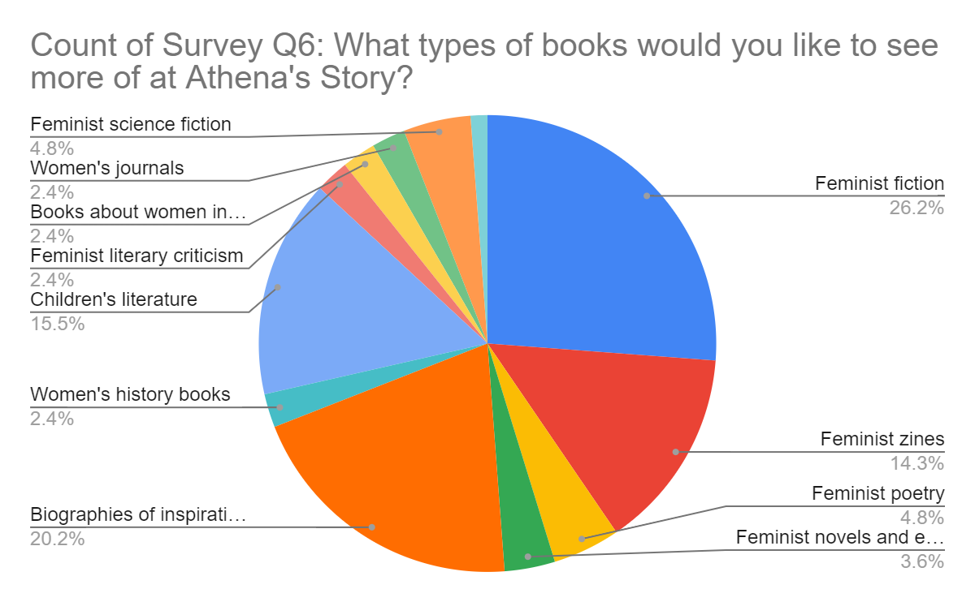Pie chart categories: -Feminist science fiction 4.8% -Books about women 2.4% -Women's journals 2.4% -Feminist literary criticism 2.4% -Children's literature 15.5% -Women's history books 2.4% -Biographies of inspiration 20.2% -Feminist fiction 26.2% -Feminist zines 14.3% -Feminist poetry 4.6% -Feminist novels 3.6%

**Fill in the blank: The visualization you create demonstrates the percentages of each book genre that make up the total number of survey responses. It’s called a \_\_\_\_\_ chart.**

**1 / 1 point**



doughnut



area



bubble



pie

**Correct**

The visualization is called a pie chart.

### 4.

Question 4

Now that you’ve confirmed that children’s literature and feminist zines are among the most requested book genres, you review the Historical Sales dataset.

To use the template for the dataset, click the link below and select “Use Template.”

Link to template: [Historical Sales](https://docs.google.com/spreadsheets/d/1HO8B-svc3Mmm3hlWycvX61Boxl9RQv6nKKWnkRig83E/template/preview).

OR

If you don't have a Google account, you can download the CSV file directly from the attachment below.

**[HistoricalSales - HistoricalSales](https://d3c33hcgiwev3.cloudfront.net/ta9P5mnbRZevT-Zp2wWXMw_dbd2edcd01804aa49f17fef80cc70f95_HistoricalSales---HistoricalSales.csv?Expires=1679529600&Signature=UnbuZ--buIizOvoCQsg5qaN1LpsSFikKBuQBS0Q-FEVf~qXbSDYjXc4lr-NKmIQ-j-96WhrvbRQ65mNVJvpJgrZtKNttDcP66CZ0PuYaW8obLUO06YxaClEfezroRJXGFBtbiVfpNeAqUQYdZEJPGob4iOJ~a4644UhEhfHcGUs_&Key-Pair-Id=APKAJLTNE6QMUY6HBC5A" \t "_blank)**

[CSV File](https://d3c33hcgiwev3.cloudfront.net/ta9P5mnbRZevT-Zp2wWXMw_dbd2edcd01804aa49f17fef80cc70f95_HistoricalSales---HistoricalSales.csv?Expires=1679529600&Signature=UnbuZ--buIizOvoCQsg5qaN1LpsSFikKBuQBS0Q-FEVf~qXbSDYjXc4lr-NKmIQ-j-96WhrvbRQ65mNVJvpJgrZtKNttDcP66CZ0PuYaW8obLUO06YxaClEfezroRJXGFBtbiVfpNeAqUQYdZEJPGob4iOJ~a4644UhEhfHcGUs_&Key-Pair-Id=APKAJLTNE6QMUY6HBC5A" \t "_blank)



You’re pleased to see that the dataset contains data that’s specific to children’s literature and feminist zines. This will provide you with the information you need to make data-inspired decisions. In addition, the children’s literature and feminist zines metrics will help you organize and analyze the data about each genre in order to determine if they’re likely to be profitable.

**Next, you calculate the total sales over 52 weeks for children’s literature. What is the correct syntax?**

**1 / 1 point**



=MAX(D2:D53)



=COUNT(D2:D53)



=CALCULATE(D2:D53)



=SUM(D2:D53)

**Correct**

The correct syntax is =SUM(D2:D53). The SUM function adds the values of a range of cells. D2:D53 is the specified range.

### 5.

Question 5

**Scenario 1 continued**

After familiarizing yourself with the project and available data, you present your approach to your supervisor. You provide a scope of work, which includes important details, a schedule, and information on how you plan to prepare and validate the data. You also share some of your initial results and the pie chart you created.

In addition, you identify the problem type, or domain, for the data analysis project. You decide that the historical sales data can be used to provide insights into the types of books that will sell best during Women’s History Month this coming year. This will also enable you to determine if Athena’s Story should begin selling more children’s literature and feminist zines.

**Using historical data to make informed decisions about how things may be in the future is an example of which problem domain?**

**1 / 1 point**



Making predictions



Spotting something unusual



Identifying themes



Discovering connections

**Correct**

Using historical data to make informed decisions about how things may be in the future is an example of making predictions.

### 6.

Question 6

**Scenario 2, questions 6-10**

You’ve completed this program and are now interviewing for your first junior data analyst position. You’re hoping to be hired by an event planning company, Patel Events Plus. Access the job description below:

**[Junior Data Analyst Job Description.pdf](https://d3c33hcgiwev3.cloudfront.net/IghHtOTaQbOIR7Tk2hGz0g_43e9ed84db0346588a8a5da2f0092380_Junior-Data-Analyst-Job-Description.pdf?Expires=1679529600&Signature=TFs1JqsDIgS7y5xBS~x2tTHScC3jWSI2wo5hMtMqFwlxtAc~K50JSdcL~NG9rChyEpfyBKW7TDcPavDaSdA9TY~W0sfyHM-XIks7dou8lWUbTtnSnCrIU3RiKuk6pd3W0PiqKG7w9UMgEaFJFY4UI42Mb5J6iNnrKCN7E8OSV40_&Key-Pair-Id=APKAJLTNE6QMUY6HBC5A" \t "_blank)**

[PDF File](https://d3c33hcgiwev3.cloudfront.net/IghHtOTaQbOIR7Tk2hGz0g_43e9ed84db0346588a8a5da2f0092380_Junior-Data-Analyst-Job-Description.pdf?Expires=1679529600&Signature=TFs1JqsDIgS7y5xBS~x2tTHScC3jWSI2wo5hMtMqFwlxtAc~K50JSdcL~NG9rChyEpfyBKW7TDcPavDaSdA9TY~W0sfyHM-XIks7dou8lWUbTtnSnCrIU3RiKuk6pd3W0PiqKG7w9UMgEaFJFY4UI42Mb5J6iNnrKCN7E8OSV40_&Key-Pair-Id=APKAJLTNE6QMUY6HBC5A" \t "_blank)

So far, you’ve successfully completed the first round of interviews with the human resources manager and director of data and strategy. Now, the vice president of data and strategy wants to learn more about your approach to managing projects and clients. Access the email you receive from the human resources director below:

**[Human Resources Director Email.pdf](https://d3c33hcgiwev3.cloudfront.net/1hlS2UUyQSqZUtlFMhEq6Q_5d4b197ec3c14762ae78f234cd31bca0_Human-Resources-Director-Email.pdf?Expires=1679529600&Signature=S~i3~BZ-RTtGK1rCAcePKXAYp7mZxuA-ExpMHNRu3SGfivVREOfmw-wdrwEcDl9TqE7wyzzpiUniYnVfEUhw9poSbLGxXZ04SLe7Vy7HGYVWPTzy5Kj0Gd8ioNYpf~FfWHeEeQyACbnO67~KjLBxKIKG5J6fJz2EEZ0giBRF~WQ_&Key-Pair-Id=APKAJLTNE6QMUY6HBC5A" \t "_blank)**

[PDF File](https://d3c33hcgiwev3.cloudfront.net/1hlS2UUyQSqZUtlFMhEq6Q_5d4b197ec3c14762ae78f234cd31bca0_Human-Resources-Director-Email.pdf?Expires=1679529600&Signature=S~i3~BZ-RTtGK1rCAcePKXAYp7mZxuA-ExpMHNRu3SGfivVREOfmw-wdrwEcDl9TqE7wyzzpiUniYnVfEUhw9poSbLGxXZ04SLe7Vy7HGYVWPTzy5Kj0Gd8ioNYpf~FfWHeEeQyACbnO67~KjLBxKIKG5J6fJz2EEZ0giBRF~WQ_&Key-Pair-Id=APKAJLTNE6QMUY6HBC5A" \t "_blank)

You arrive Thursday at 1:45 PM for your 2 PM interview. Soon, you’re taken into the office of Mila Aronowicz, vice president of data and strategy. After welcoming you, she begins the behavioral interview.

First, she hands you a copy of Patel Events Plus’s organizational chart. Access the chart below:

**[Patel Event Plus Org Chart.pdf](https://d3c33hcgiwev3.cloudfront.net/k1nn8EThT1eZ5_BE4f9XlA_83cdce6aa225430bb76a9d66e23eab2d_Patel-Event-Plus-Org-Chart.pdf?Expires=1679529600&Signature=NHTxnXI2cqo~ArkulP0gK-OcPfhZKJnqHe~r89hXHrJHdhtKRVwGk~kCCO6W33nE1RrqmuSYNUhONFSjQEytZCZZVKDcIALvJQwZoB2Xn-aDwp9ZX7Sa9k8C5EREpuTHxkJBcJWvq5VySP1YR8ySwTGQf2ffNNHDQ-CCB7NQDVU_&Key-Pair-Id=APKAJLTNE6QMUY6HBC5A" \t "_blank)**

[PDF File](https://d3c33hcgiwev3.cloudfront.net/k1nn8EThT1eZ5_BE4f9XlA_83cdce6aa225430bb76a9d66e23eab2d_Patel-Event-Plus-Org-Chart.pdf?Expires=1679529600&Signature=NHTxnXI2cqo~ArkulP0gK-OcPfhZKJnqHe~r89hXHrJHdhtKRVwGk~kCCO6W33nE1RrqmuSYNUhONFSjQEytZCZZVKDcIALvJQwZoB2Xn-aDwp9ZX7Sa9k8C5EREpuTHxkJBcJWvq5VySP1YR8ySwTGQf2ffNNHDQ-CCB7NQDVU_&Key-Pair-Id=APKAJLTNE6QMUY6HBC5A" \t "_blank)

As you’ve learned in this course, stakeholders are people who invest time, interest, and resources into the projects you’ll be working on as a data analyst. Let’s say you’re working on a project involving data and strategy. **Based on what you find in the organizational chart, if you need information from the primary stakeholder, who can you ask?**

**0 / 1 point**



Project manager, analytics



Vice president, data and strategy



Chief executive officer



Director, strategy

**Incorrect**

Review [the video on primary and secondary stakeholders](https://www.coursera.org/learn/ask-questions-make-decisions/lecture/QJ5qG/focus-on-what-matters) for a refresher.

### 7.

Question 7

**Scenario 2 continued**

Next, the vice president wants to understand your knowledge about asking effective questions. Consider and respond to the following question. Select all that apply.

**Let’s say we just completed a big event for a client and wanted to find out if they were satisfied with their experience. Provide some examples of measurable questions that you could include in the customer feedback survey.**

**1 / 1 point**



What problems did you experience with our events team?



What did you most love about your event experience?



On a scale from 1 to 5, with 1 being not at all likely and 5 being very likely, how likely are you to recommend Patel Events Plus?

**Correct**

In the SMART methodology, measurable questions can be quantified and assessed. This might include a 1-to-5 scale or questions with ranked responses.



How satisfied were you with our event planning service — dissatisfied, neutral, or satisfied?

**Correct**

In the SMART methodology, measurable questions can be quantified and assessed. This might include a 1-to-5 scale or questions with ranked responses.

### 8.

Question 8

Now, the vice president presents a situation having to do with resolving challenges and meeting stakeholder expectations. Consider and respond to the following question. Select all that apply.

**You’re working with a dataset that the data analytics coordinator should have cleaned, but it turns out that it wasn’t. Your supervisor thought the dataset was ready for use, but you discover nulls, redundant data, and other issues. The project is due in less than two weeks. Which of the following options would be an appropriate approach?**

**0.75 / 1 point**



Email your supervisor and the data analytics coordinator to communicate about the issue. Ask if you can meet to come up with a solution.

**Correct**

This situation presents an opportunity to communicate, collaborate, and foster positive working relationships.



Provide your supervisor with a proposed revised timeline. Politely explain that you need some additional time to clean the data.

**Correct**

This situation presents an opportunity to communicate, collaborate, and foster positive working relationships.



Proceed with the project using the available data. You don’t want to get the associate data analyst in trouble, and you don’t want to miss your deadline.



Email the data analytics coordinator to ask if the two of you can work together to clean the data, as the project is on a tight timeline.

You didn’t select all the correct answers

### 9.

Question 9

**Scenario 2 continued**

Your next interview question deals with sharing information with stakeholders. Consider and respond to the following question.

**Let’s say you want to share information about an upcoming event with stakeholders. It’s important that they’re able to access and interact with the data in real time. Would you create a report or a dashboard?**

**1 / 1 point**



Dashboard



Report

**Correct**

Dashboards offer live monitoring of incoming data and enable stakeholders to interact with the data.

### 10.

Question 10

**Scenario 2 continued**

Your final behavioral interview question involves using metrics to answer business questions. Your interviewer hands you a copy of a Patel Events dataset.

To use the template for this dataset, click the link below and select “Use Template.”

Link to template: [Patel Events Data](https://docs.google.com/spreadsheets/d/1q2opRSUOWoK5KxPHFpqupOyDpJyob9t_kf-GOf90szE/edit#gid=1888255122)

OR

If you don't have a Google account, you can download the CSV file directly from the attachment below.

**[Patel Events Plus dataset](https://d3c33hcgiwev3.cloudfront.net/H0ow0rvpTW2KMNK76W1taQ_1f687892bdc64c83bfba59f168c7a41e_Patel-Events-Plus-dataset.csv?Expires=1679529600&Signature=K5Y93ybtkitAgMjU5pc7Y0sSfAzia-2Wf-psdqZYNbcV4wxMSqhUrn6pz~oTS~xfip805-8KmbQ~jCEkGfr~XFwNF-fgwd1KyLJFN5WHnrwllf4RknJl4gU3cm8sLP6pIgGD0uacSS0jiTjj4Nso6wWRi7YWKMlniKvC2V2t7b4_&Key-Pair-Id=APKAJLTNE6QMUY6HBC5A" \t "_blank)**

[CSV File](https://d3c33hcgiwev3.cloudfront.net/H0ow0rvpTW2KMNK76W1taQ_1f687892bdc64c83bfba59f168c7a41e_Patel-Events-Plus-dataset.csv?Expires=1679529600&Signature=K5Y93ybtkitAgMjU5pc7Y0sSfAzia-2Wf-psdqZYNbcV4wxMSqhUrn6pz~oTS~xfip805-8KmbQ~jCEkGfr~XFwNF-fgwd1KyLJFN5WHnrwllf4RknJl4gU3cm8sLP6pIgGD0uacSS0jiTjj4Nso6wWRi7YWKMlniKvC2V2t7b4_&Key-Pair-Id=APKAJLTNE6QMUY6HBC5A" \t "_blank)



Then, she asks: Recently, Patel Events Plus purchased a new venue for our events. **If we asked you to calculate the return on investment of this purchase, the metrics to consider would be the cost of the investment and what else?**

**1 / 1 point**



Average event revenues



Purchase date



Net profit in 2019



2019 events held at new venue

**Correct**

Return on investment is made up of two metrics: the net profit over a period of time and the cost of the investment. By comparing these two metrics, you can determine the profitability of the investment.